**BDC Building COVID-19 Screening**

There is a **mandatory** COVID-19 screening for patients, and visitors entering the **BDC building**

* **Arrive 5 minutes early:** The screening will add time to your entry.
* 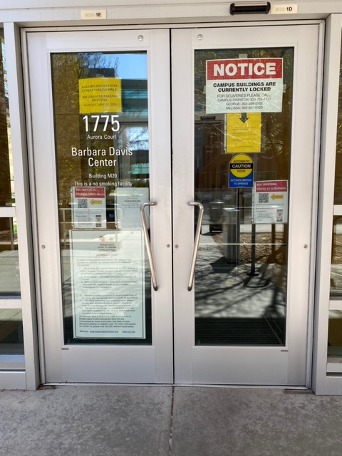**Use the only entry point: North-West entrance** to the lobby:



Point **your cell phone’s camera** to the QR code indicated by the yellow arrow, and click a link to RedCap that will appear at the top of your screen.

If you forgot your cell phone, a tablet backup is available

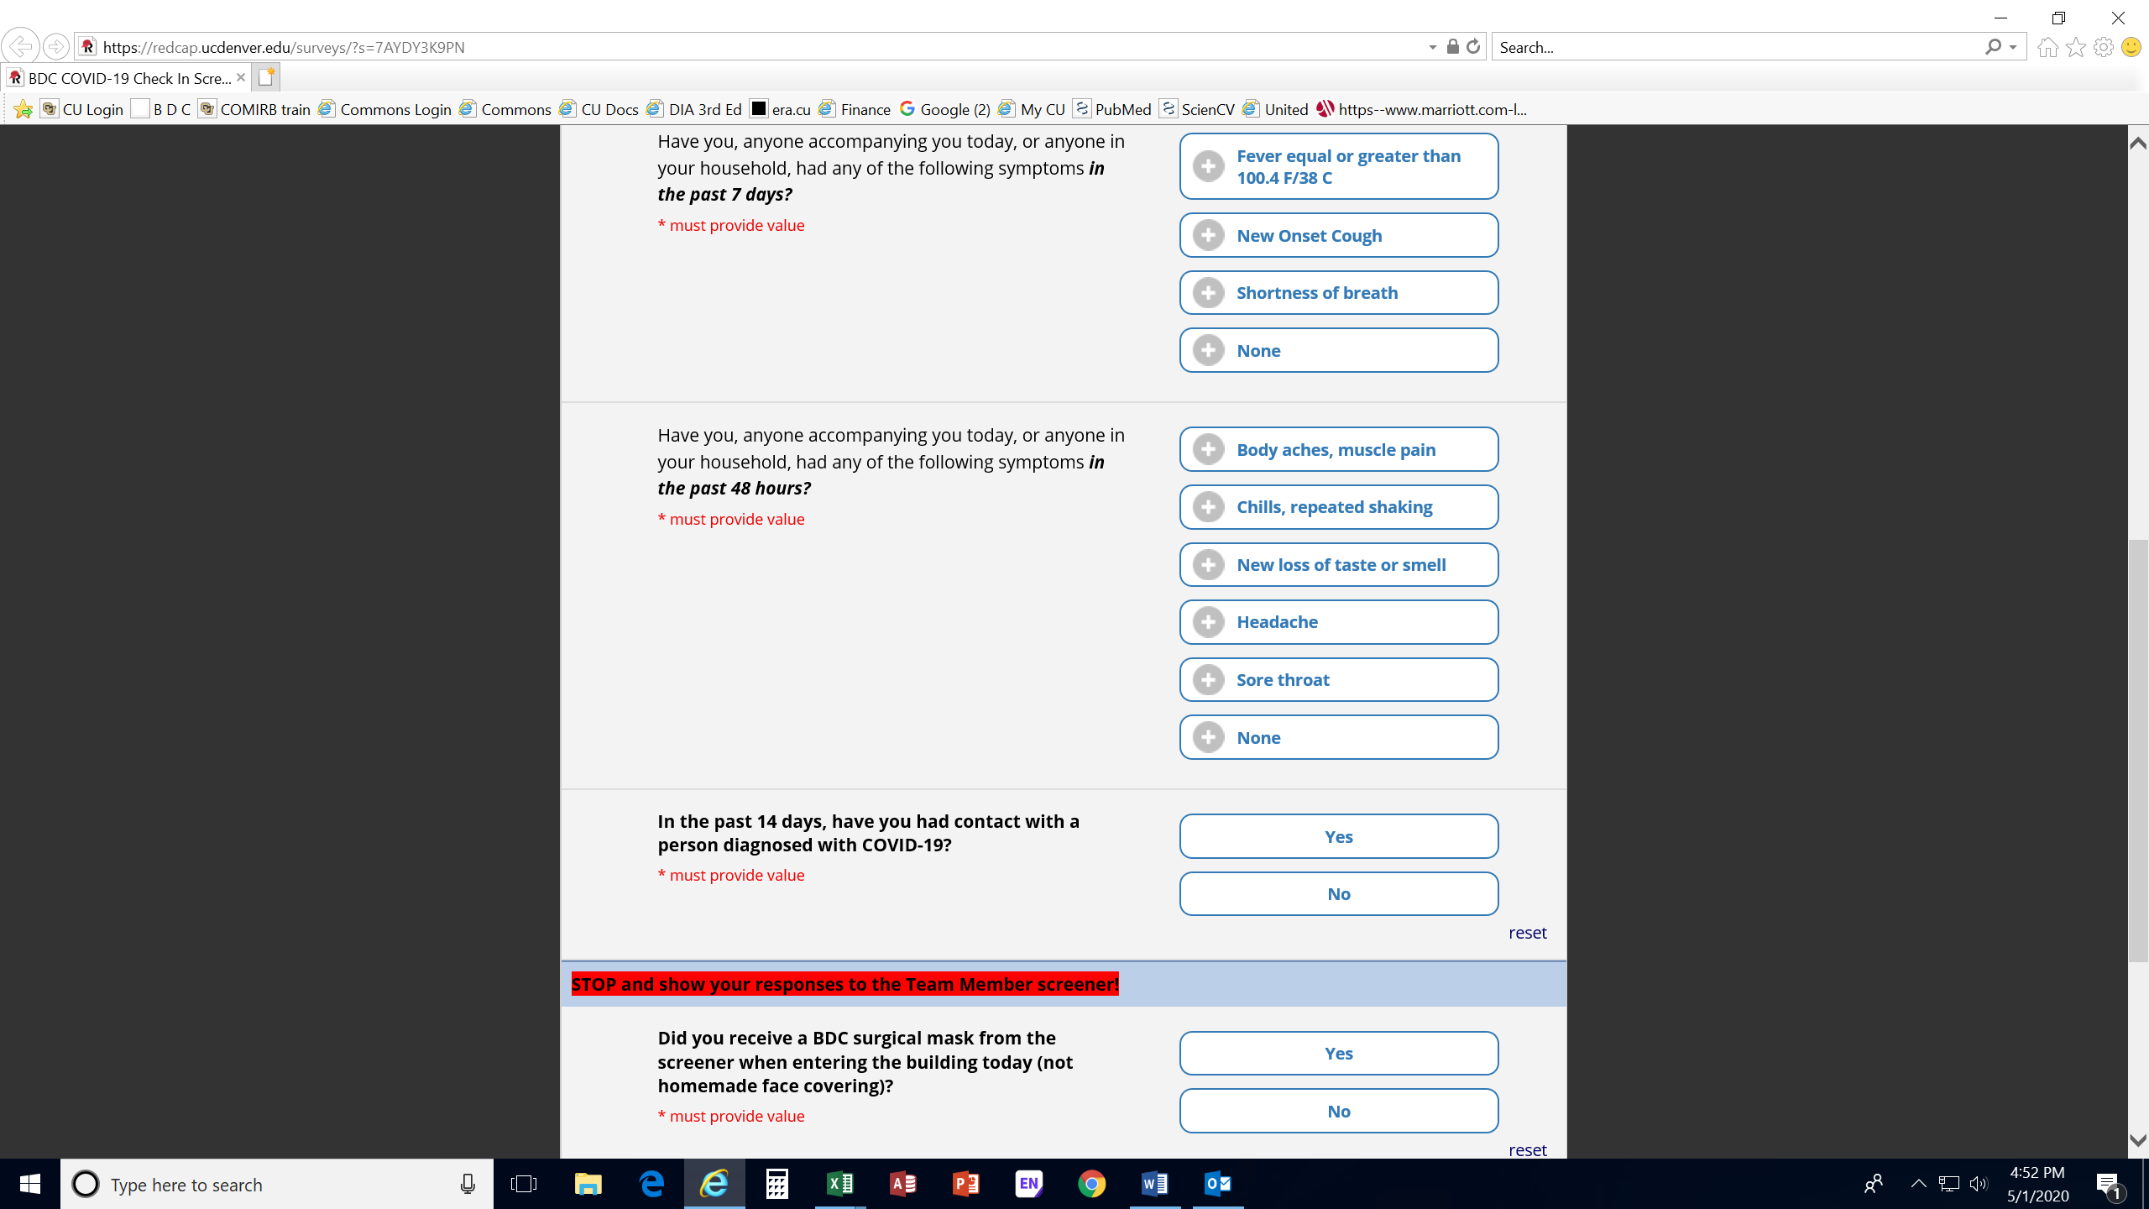**On your phone you must complete a questionnaire, including:**

**Stay home and reschedule your visit if** you have experienced any of the symptoms prior to your visit

**Complete the questionnaire (but don’t submit it) and proceed to the lobby were 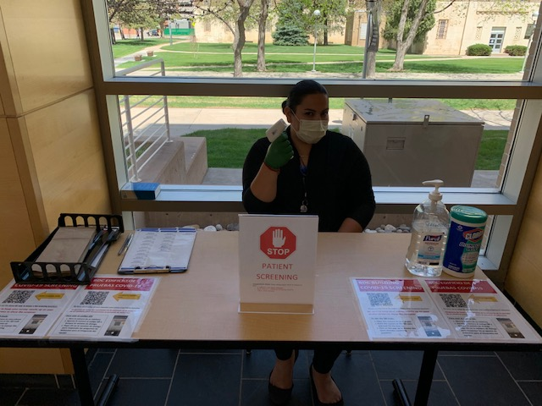a screener with check your temperature…**

* + **≥ 100.4 F – no entry allowed**
  + 99.0 - 100.3 F – additional screening required
  + **<99.0 –entry allowed**
* **check if you have a face mask:** you will receive a new surgical mask or you may use your cloth or surgical mask
* **and will give you a sticker** good for re-entry that day

Thank you for your patience as we work to protect our team members and our community!

​