Build your home dialysis emergency plan
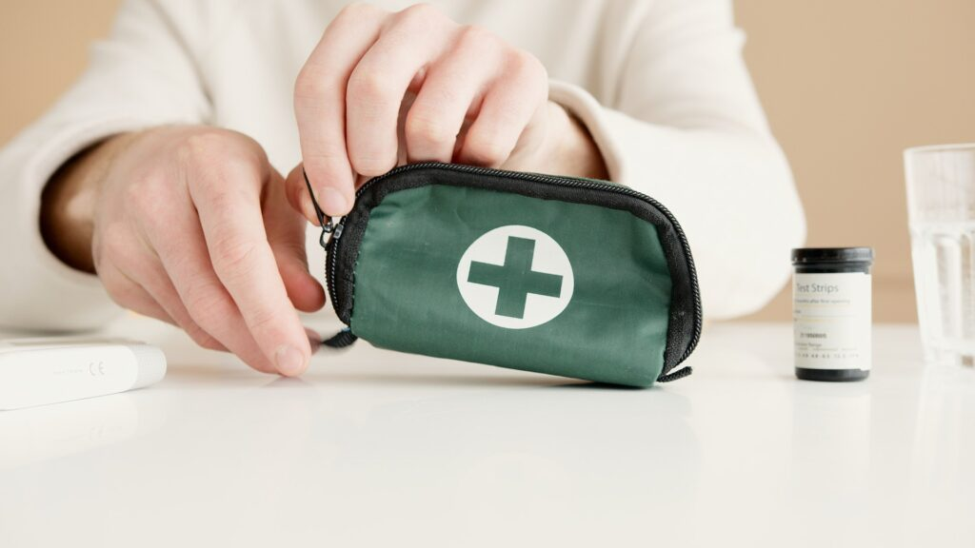
No one wants to imagine a situation where they’re dialyzing at home when an emergency occurs, such as losing power or severe weather events. Hopefully, you’ll never find yourself in such a situation, but having a plan ready can help you feel more secure and prepared in the face of an emergency. Here are a few things to include in your home dialysis emergency plan.

Know your backup treatment facilities
Have a list of nearby dialysis centers you could go to in case your power goes out or if you are suddenly unable to dialyze at home. Cincinnati Home Dialysis offers in-center treatment, but be sure to include several centers on your list in case of widespread power outages and emergency conditions.

Keep extra supplies on hand
Always have at least a two-week supply of home dialysis materials in case of emergencies. Be sure to check the expiration dates regularly and replenish your stash as needed.

Maintain an emergency kit
A well-stocked first aid kit is essential for everyone! Be sure your kit includes different types of bandages, antiseptic wipes, splints, gauze, gloves, antibiotic ointment, a cold compress, and one week supply of your medications, at minimum. Consider keeping non-medical emergency supplies like flashlights with extra batteries, candles with lighters, a fire extinguisher, radio, and emergency blankets nearby.

Update your contact lists
Keep a list of emergency contacts and your medical providers in various places, including in your emergency kit, at your workplace, and with a trusted friend or neighbor nearby.

Learn how to stop home dialysis abruptly
As part of your home dialysis training, your care team will teach you how to disconnect from your machine in emergency situations. Continuing to walk through the steps of this procedure will keep it fresh in your mind.

Talk to your power and water providers
Let both your electric and water companies know about your medical treatment needs at home so service to your home can quickly be restored.

Cincinnati Home Dialysis Blog

