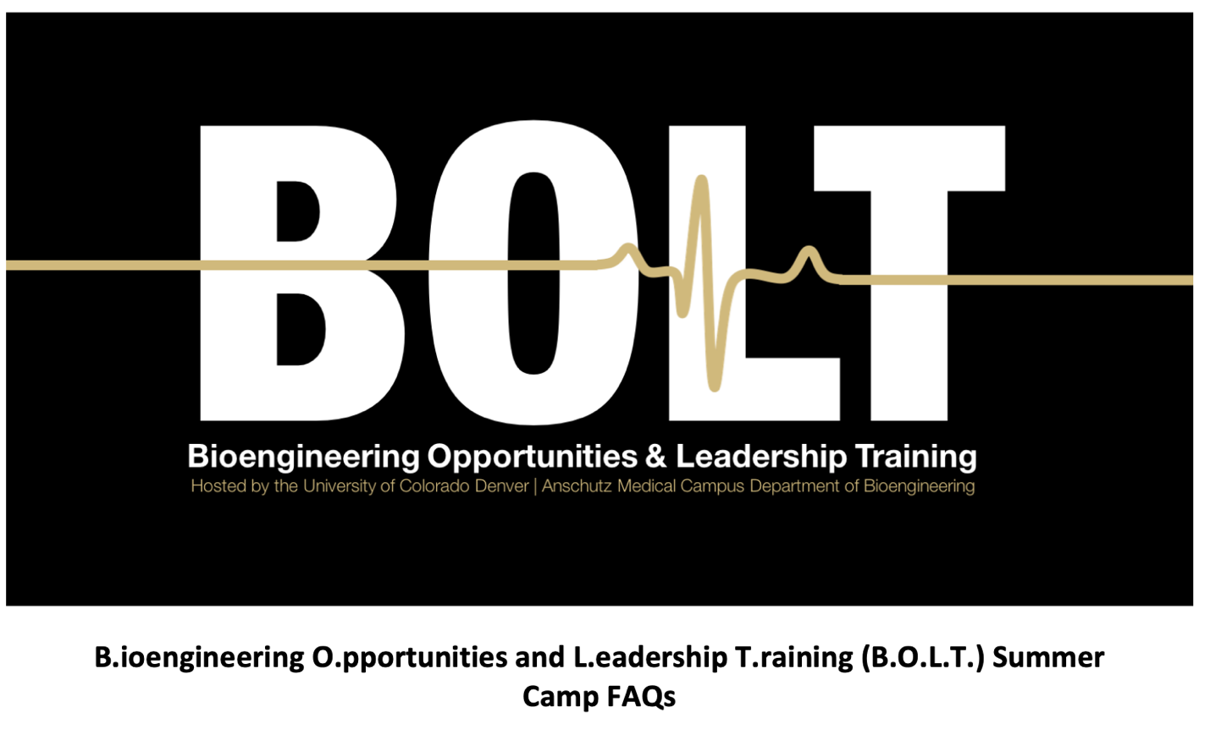
What is Online BOLT?
Online BOLT, Bioengineering Opportunities and Leadership Training, is a three-day experience for high school students who are passionate about bringing together biology, engineering, and medicine for the advancement of human health. Online BOLT is a fully virtual camp that is taking place during summer 2020 instead of our normal in-person camp which traditionally takes place at Anschutz Medical Campus.

When is Online BOLT?
Online BOLT Session 1: July 27-29 from 8:30-4:30, through ZOOM

Online BOLT Session 2: August 3-5 from 8:30-4:30, through ZOOM

There will be a 1 hour lunch break each day and some of the sessions will be reserved for students to build prototypes during these hours or work in small groups through zoom breakout rooms, the entire day will not be lectures or content delivery through zoom but it is expected that students plan to be working on BOLT activities or participating in the zoom sessions during these hours. This is a live-synchronous camp.

Is online BOLT a good fit for me?
To gain the most from B.O.L.T., students should have taken high school biology by the time they attend. Although it is not a requirement, students who have completed high school biology will likely be able to take more away from the camp. We welcome students entering freshman year of high school but recommend self-directed students as the course will be online and will require virtual teamwork.

What can I expect for the three days of online BOLT?
BOLT is a camp for high schoolers that teaches them about biomedical engineering and the many career options available for STEM-focused students. Though the experience will be different than the in-person camp the Department of Bioengineering typically hosts at Anschutz, virtual BOLT will still be filled with interesting topics and activities designed to introduce high school students to biomedical engineering and leadership topics.

Student teams will virtually work together to design, build, test, and iterate to create prototype prosthetic hands to compete in an engaging, yet laid-back design competition. In parallel, students will learn about what biomedical engineering is, dive into the theory of general engineering principles, and get a sneak peek of cutting-edge upper limb prosthetics research. We are also developing a hands-on circuit activity to introduce and demonstrate key concepts in prosthetics control.

Once you have signed up, we will reach out with more details about the schedule in mid-June.

What supplies do I need for BOLT?
We will either mail out or have pick-up options for you to get the kit of supplies you need for BOLT. All you need is access to a computer that has a webcam for zoom, and a little space (desk or table) to be able to do some simple prototyping and building with the kits we provide.

What skills will students gain by attending BOLT?
BOLT will provide students with the opportunity to look at many different aspects of bioengineering. Students will be introduced to electronics, the engineering design process, interacting with peers and biomedical engineers as well as exposure to physiology and biology.

Are there scholarships available?
Yes, we have partial and almost-full scholarships available for those who demonstrate need. Please go to the scholarship link at the website. Please complete the application and then we will notify of you of your acceptance and then we will send you the registration link.

