FA Disability Committee
Meeting Notes from March 27, 2024, 12:00-1:00 PM
Committee Members Present:
Colleen Donnelly (Chair), CLAS/English
Thorsten Spehn (VC and Secretary), CLAS/PolSci
Maureen Melonis, Bioengineering
Pepe Sánchez, SPA
Matthew O’Brien, CAM
Sophie Cook, CAM
Kyle Ehrhardt, Business

Past Meeting Minutes:
Meeting minutes from Feb 21, 2024 approved.

Spring Fling Report

Discussion of Spring Fling event. It was a relatively small gathering, but it was successful. VC Farias was there in addition to Chancellor Marks and her personal assistant. Colleen expressed her thanks to CAM who organized student support. The students were awesome!

Sophie suggested that Kailen from Wheelchair Sports Camp be presented with her UCD diploma which she did not receive because she did not pay a library fee. Sophie wants to reach out to Deans to get the diploma, plan a ceremony and maybe, get additional people involved, have Kailen talk about her activism for the disabled community.

Accessibility Practices Certificate

Discussion of past and future programming through the CFDA, including some pushback from TIPS on the issue of certification. There is currently no standard on certificates although there is a working group developing guidelines. In any case, faculty can not be subject to standards developed by TIPS.

Student Poster and Sticker Discussion

DisC is teaming up with CAM to have students design posters and a logo. Posters are to be used for a social media campaign.

Report on student “pitch” presentation from March 26 which was attended by Sophie, Colleen, Amy and Thorsten. Different color schemes, fonts and images were discussed and suggested. The logo was subsequently redesigned with input from other committee members including Pepe Sánchez with the image of a brain added to the head of the person in the wheelchair. Here is the final image:

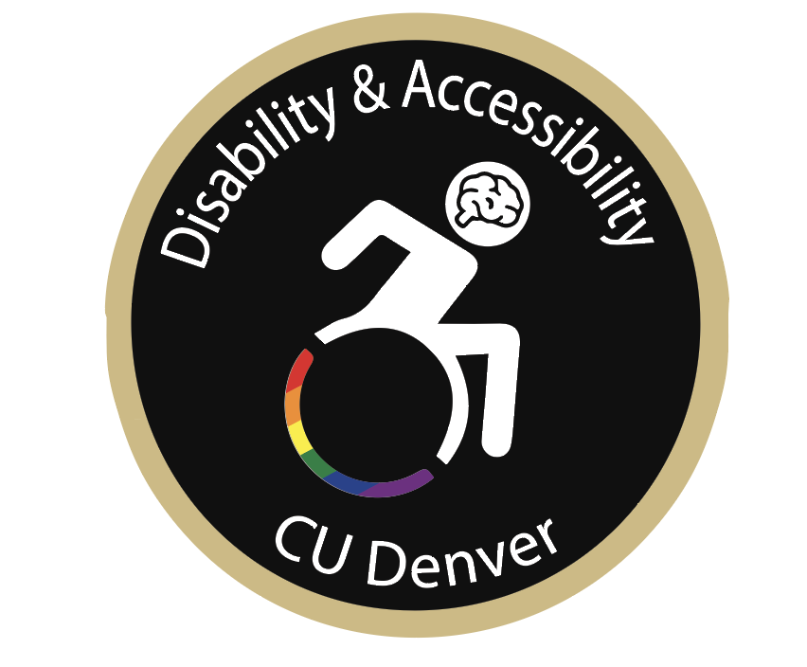

Brainstorming Session on Future Projects

Short discussion on this. Potentially get greater student involvement through research projects like the one done by Peter Anthamatten in which a student is mapping accessibility on our campus.

