Managing a Hybrid Team

Participant Guide

Learning and Development

Managing a Hybrid Team

Course Objectives
- Describe the key components to managing a hybrid team
- Understand, based on University Policy, what to consider when making decisions on remote and hybrid work arrangements
- Develop an action plan for managing a hybrid team
- Identify additional resources on managing hybrid teams

Course Etiquette
- Listen actively and attentively.
- Ask for clarification if you are confused.
- Do not interrupt on another.
- Challenge one another, but do so respectfully.
- Build on one another’s comments; work towards shared understanding.
- One person speaks at a time.
- Speak from you own experience, without generalizing.
- Consider anything that is said in class to be strictly confidential.

Agenda
Course Objectives 2
Course Etiquette 2
Agenda 2
Opening Discussion – Chat Exercise 4
Keys to Managing a Hybrid Team Model 4

Breakout Room Exercise – Keys to Managing a Hybrid Team 5
Maintain Awareness 6
Create an Atmosphere of Trust and Fairness 8
Understand What Drives Your Team 9
Set Clear Expectations 9
Establish Open Lines of Communication 11
Use Multiple Communication Channels 12
Be Open to Doing Things Differently 13
Remote and Hybrid Work Arrangement Considerations 14
Additional Resources 16

Personal Action Plan Instructions 16

Managing a Hybrid Team Handout Packet 17

LinkedIn Learning 17
Summary 17

Opening Discussion – Chat Exercise
How does our perspective need to shift as managers as we move into managing a hybrid workforce?

Keys to Managing a Hybrid Team Model
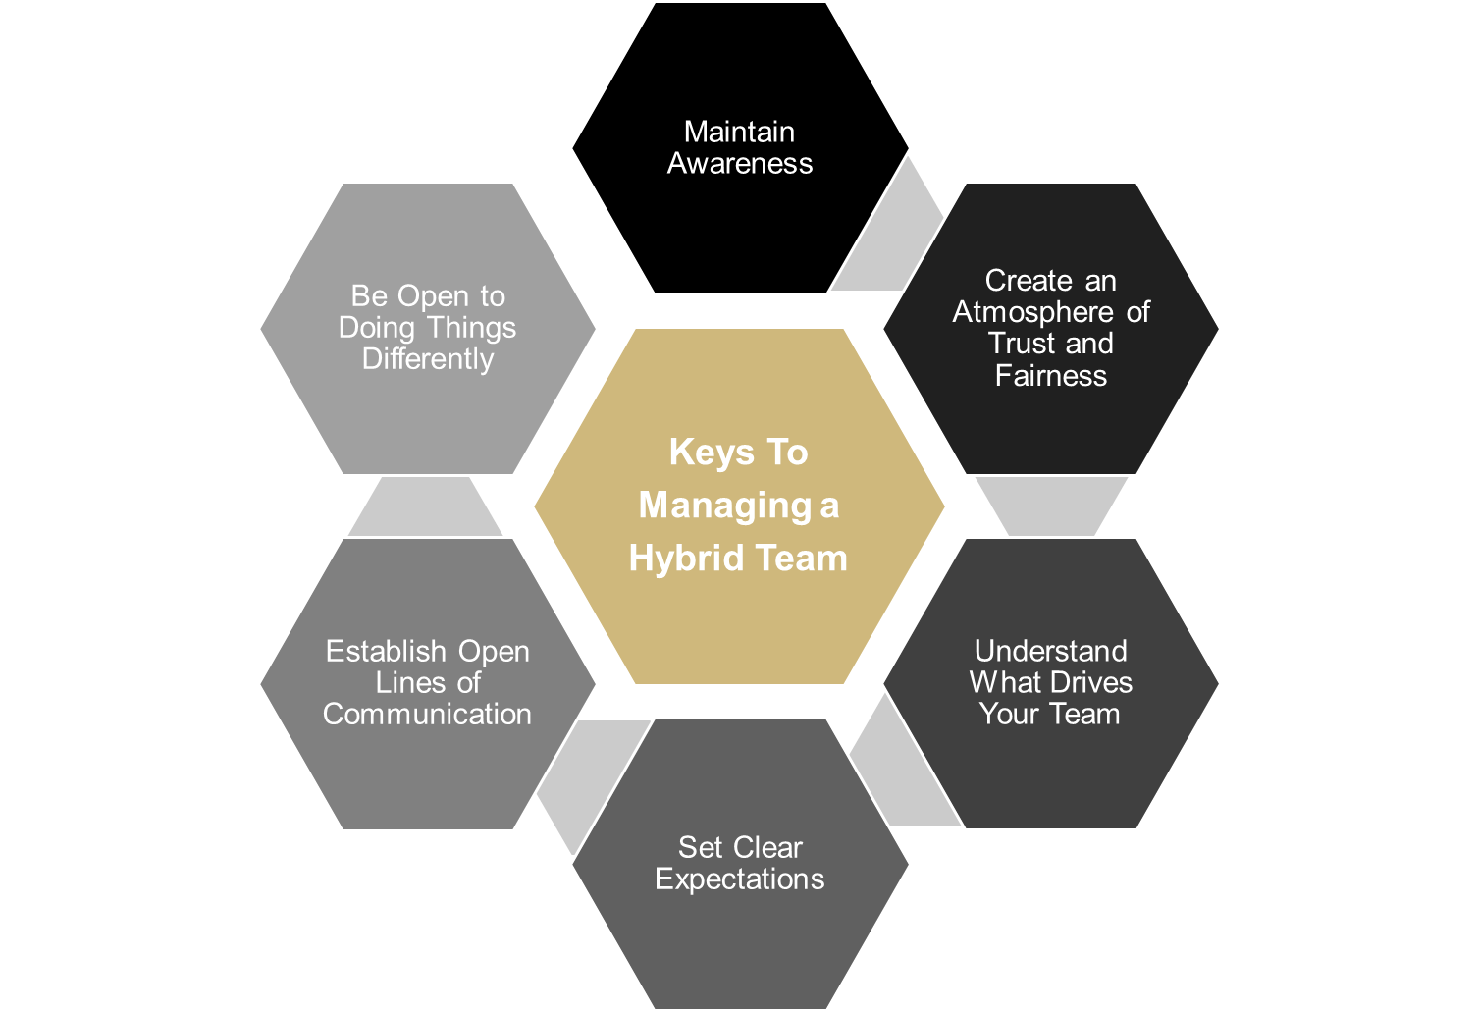
Model Notes:

Breakout Room Exercise – Keys to Managing a Hybrid Team
In your breakout rooms, brainstorm the following:
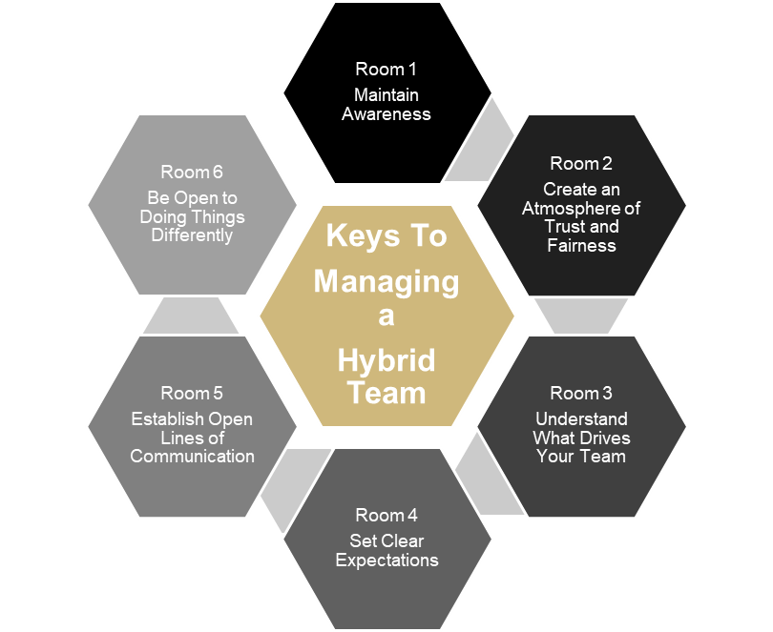
- What skills does a manager need to be competent in that area?
- What struggles might a manager face in that area?

Use the PadLet feature to record your answers. Pick a spokes person to report out for your team. You will have 10 minutes in your breakout room for this exercise.

Maintain Awareness
Individuals Have Different Experiences
Remember: Whether working remotely or in-person, individuals are having different experiences and seeing work through a different perspective.

Manage the Individual, NOT the Environment
Remember: Regardless of where an employee works, as a manager, it is important to understand what motivates and drives each person.

Be conscious of Your Own Tendencies / Behaviors
Remember: Know your own tendencies and ask yourself questions such as:
- How do I prefer to communicate? In Person? Email? Pop into your office?
- When I conduct virtual meetings do I remember to engage remote employees? Do I or others hold side-bar conversations that exclude those calling in remotely?
- How do I distribute work?
- Do I make sure everyone has a chance to be heard and seen?
- Am I equally connecting with everyone?
- What are your actions saying about you as a leader?

Create an Atmosphere of Trust and Fairness
Extend Trust Through
- Creating Transparency / Sharing Information
- Empowerment and Ownership
- Avoid Micromanagement

Practice Inclusivity by
- Allowing Individuals to Participate Equally
- Spreading Workload and Visibility
- Scheduling Time to Connect

Understand What Drives Your Team
- Use assessments to understand individuals
- Work on behavior clues
- Ask what’s important to them…communication, interaction, frequency, etc.
- What drives and motivates individuals

Set Clear Expectations
- Effectively Communicate Responsibilities
- Maintain Transparency Around How Performance is Evaluated
- Set Clear Expectations Around Availability (Remote / In-Person)
- Provide Clear Feedback on Expectations / Performance

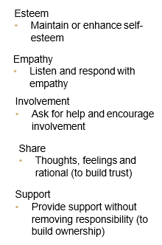
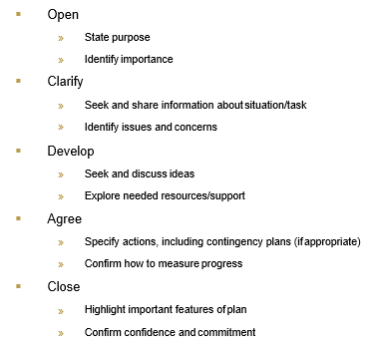

Establish Open Lines of Communication
- Establish Strong Communication Habits
  - Frequency / Consistency
  - 1:1 Meetings
  - Team Meetings
  - Medium Used
- Maintain Information Parity
  - Create a Communication Plan
  - Timely Sharing of Information
  - Communicate Important Messages

Use Multiple Communication Channels
The below chart is an example of how you can use multiple ways to communicate with your team:

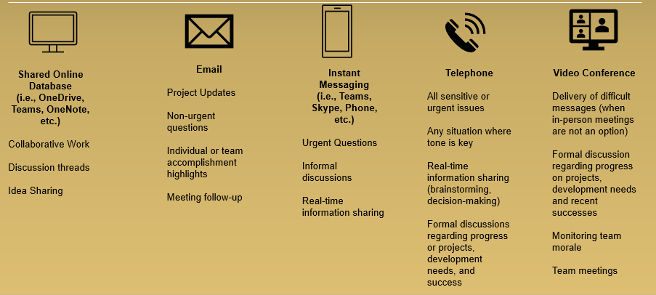

Be Open to Doing Things Differently
Remember: Effectively managing hybrid virtual teams will take an open mind and a willingness to try new things. Managers who are flexible and resilient will not only be able to support a hybrid virtual team, but they will also be able to tap into new, innovative ways of accessing their team, finding new ways to improve processes, and developing high performing teams.

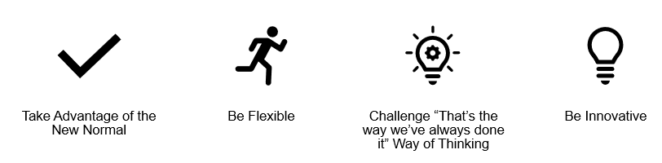

Remote and Hybrid Work Arrangement Considerations
Based on University policy, supervisor and/or appointing authorities determine whether an alternative schedule or remote (or partially remote) work is appropriate based on essential duties or employee’s job/role and the needs of the University.
Supervisors and/or appointing authorities determine whether an alternative schedule or remote (or partially remote) work is appropriate based on the essential duties of each employee’s job/role and the needs of the University. With respect to remote work (or partially remote work) an assessment should be made on a case-by-case basis to determine whether the work needs to be conducted entirely on-campus, partially on-campus (hybrid), or entirely remotely. Alternative work schedules and/or remote work is an option, not an entitlement, and such arrangements do not change the terms and conditions of employment. A unit or school may decide not to permit alternative work schedules and/or remote work due to the nature of their operations.
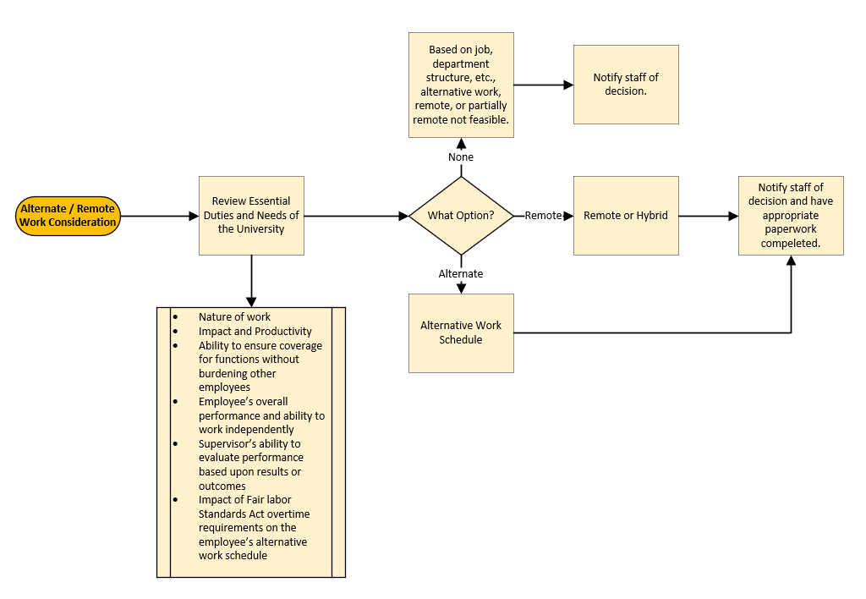

Additional Notes:

Additional Resources

Personal Action Plan Instructions
Included with this package is a Personal action plan. The following are guidelines on how to use this document:
- After the class, review each of the six sections and the notes from the class. Determine one or more (I suggest no more than 3 areas) that you want to focus on for the next 90 days.
- Once you have selected the area(s), review the “Action Plan Strategies” on page two of the document. Each of the six areas has recommendations as to items that can help you increase your skills/competencies/awareness in that area.
- Select an item from the strategies list and build your action steps and record on page one.
- Next, determine what you want the anticipated outcome(s) to look like and record that on your plan.
- Review your plan on a regular basis to ensure you are making progress.
- At the end of the 90-days, reflect on where you were prior to focusing on the selected are and determine your next steps.
Example Action Plan:

Focus Area | Action Steps | Anticipated Outcome
Maintain Awareness

Create Atmosphere of Trust and Fairness

Understand What Drives Your Team | Schedule team DISC session | Gain a better understanding of team dynamics and how members prefer to communicate. Break down communication barriers.
Set Clear Expectations | Develop team norms around virtual meetings | Set expectations as to attendance, interaction, preparedness, video, etc.
Choose one or more of the areas above and select a strategy to focus on for the next 90-days.

Managing a Hybrid Team Handout Packet
This handout includes the following articles and resources:
- Managing Zoom Fatigue
- Conducting Online Meetings Checklist
- Managing Remote Teams During the Coronavirus (COVID-19) Outbreak (article by Gartner published March 16, 2020)
- Cornell University Managing Remote Teams Guide For Manager
- How do I…Work from Home (Information from OIT)

LinkedIn Learning
- Managing Virtual Teams
- Leading at a Distance
- Leading Virtual Meetings

Summary
During this workshop, we discussed six keys to consider when managing a hybrid team. In each of these areas we explored skills and competencies a manager needs to lead an effective and high-performing team. In addition, we reviewed considerations, based on University Policy that a manager should look at when determining if a position could work on an alternative schedule, remotely or in a hybrid environment. Lastly, we provided individuals with an action plan to consider for growth opportunities while facing the challenge of managing in this new culture.

Should you have questions about your assessment or any of the content, please contact your Instructor or HR.TrainingRegistration@ucdenver.edu.

Check out our Learning and Development website for course offerings, online training resources, additional custom workshop opportunities, and so much more!

