Managing a Hybrid Team - Personal Action Plan

My Journey Begins:

Date Completed: ________________
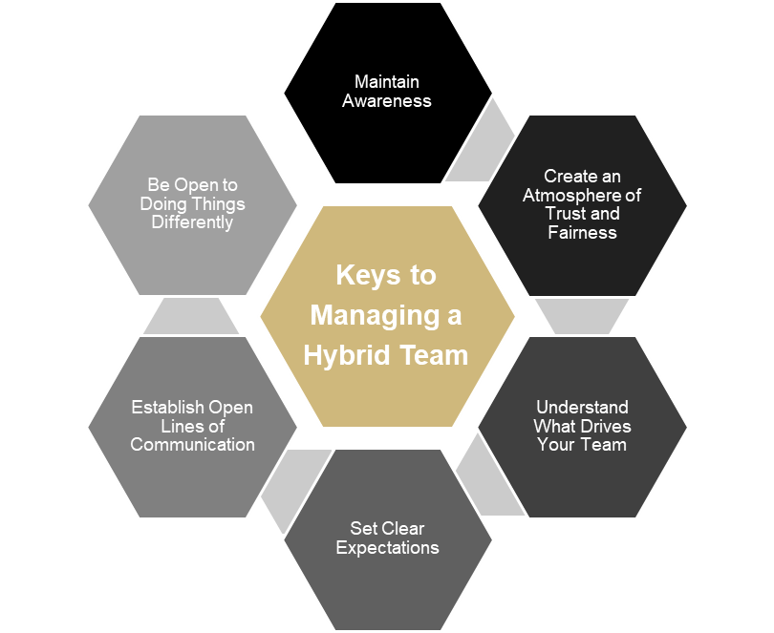

Focus Area | Action Steps | Anticipated Outcome
Maintain Awareness

Create Atmosphere of Trust and Fairness

Understand What Drives Your Team

Set Clear Expectations

Establish Open Lines of Communication

Be Open to Doing Things Differently

Choose one or more of the areas above and select a strategy to focus on for the next 90-days.

Action Plan Strategies
Maintain Awareness | Create Atmosphere of Trust and Awareness | Understand What Drives Your Team
Create cross-cultural awareness.  Develop a process for maintaining and verifying that your team have the tools they need to do their job effectively.  Be willing to provide team members with autonomy.  Provide equal time, equal mind space and equal opportunities for team members.  Eliminate unnecessary us versus them tensions between team members.  Understand your own behaviors / tendencies. | Consistently apply and follow procedures across the team.  Build a level playing field.  Develop team norms.  Make sure there is parity between workers.  Foster equality and transparency.  Keep scheduled meetings (builds trust and connectedness).  Provide assistance and guidance when needed.  Encourage team vs individual identity. | Allow team members how are experts to lead in their fields of expertise.  Giving everyone the opportunity to take charge in their area, builds trust across the team.  Provide an opportunity to build connections during team meetings.  Instill a “team” mindset.  Consider teambuilding function (DISC, Strengths, etc.).  Consider professional development opportunities for your team.
Set Clear Expectations | Establish Open Lines of Communication | Be Open to Doing Things Differently
Develop team norms.  Set clear individual and team expectations.  Provide timely and meaningful feedback.  Encourage team members to talk to each other during meetings.  Conduct regular 1:1 meetings.  Communicate timely changes in projects, priorities, and goals. | Make sure lines of communication are open – build a plan.  Communicate any changes to goals and priorities immediately (get ahead of the rumor mill).  Have frequent and regular contact with all your team members (individually and as a group).  Keep teams engaged and informed.  If change impacts some team members more than others, schedule time to meet with them separately.  Communicate, communicate, communicate. | Challenge the “this is the way we have always done it” way of thinking.  Consider looking at how current processes could be done differently.  Engage in process improvement strategies such as 5 Whys.  Provide assistance and guidance when needed.

