Schedule an Independent Study/Thesis/Internship
or other similar class
Action:
Schedule a unique class (either an advertised section, enrollment section, or both)

CU-SIS Location:
Main Menu > Curriculum Management > Schedule of Classes > Schedule New Course

- Look up the class
- Identify if you need to add a row first before beginning.

If the class number is "0" and the section number is blank, a new row isn't required:

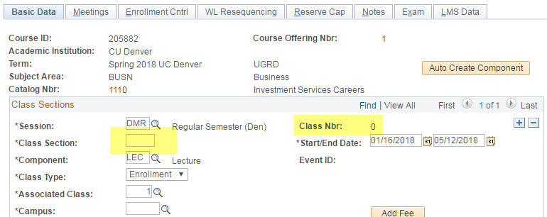

If the class number is present, you will need to add a new row before beginning:

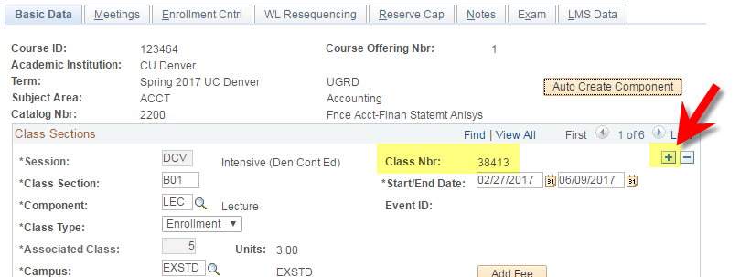

- Schedule according to the procedure below.

Tabs Used:
Fields Used:
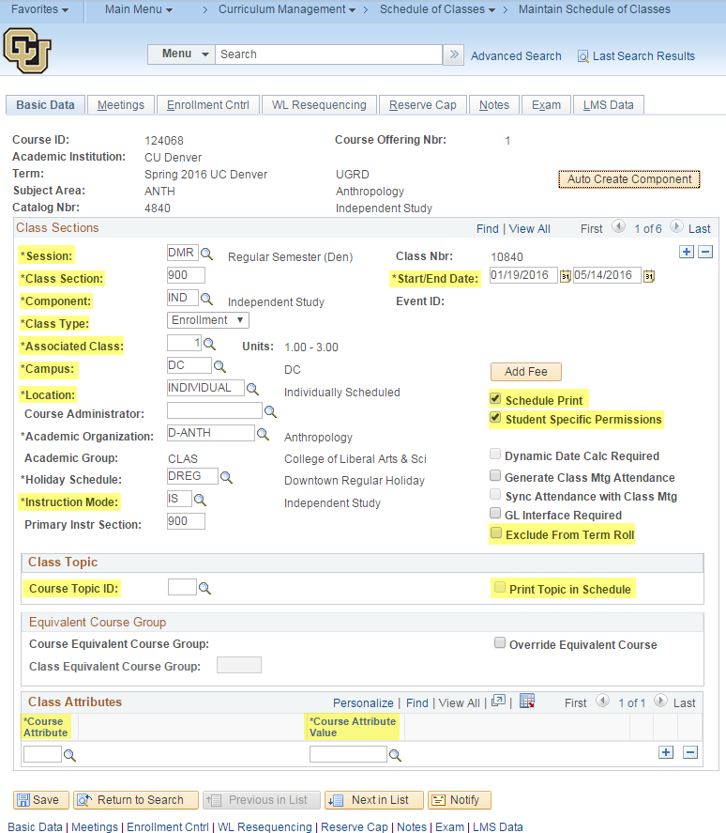

FIELD | How to complete this field
SESSION | Choose the correct session using the Session Code Calendar, available on the Curriculum Management Website. DMV/DCV should only be used if your dates do not match any of the other session code dates and are the only session codes we are allowed to edit dates for. DCV requires a meeting pattern. If selecting an intensive session, edit the dates.
CLASS SECTION | Advertised Section: 900/950  Enrollment Section: 901/951 or higher  Enter a section number that hasn't already been used for another section of this class this term. Section numbers must align with the Section Number Conventions listed on the CM website and must align with the campus and instruction mode.
COMPONENT | Enter the appropriate component (components are created and maintained in Course Inventory located at Curriculum Management>Course Catalog>Course Catalog. If you don't see the component you need when scheduling a class, contact the Curriculum Manager).
CLASS TYPE | Choose ENROLL unless scheduling a linked lecture+lab or similar set-up. NON-ENROLL is used for the lab/recitation when linked.
ASSOCIATED CLASS | Every section needs a unique number, unless it is a linked lecture+lab or similar set-up. Linked classes must share the same number.  *You will need to pay attention to this field because the system will always default to "1". "1" is fine to use if there is only one section of a class for a given term. For courses with more than one section, increase the number by 1 for each additional section.
CAMPUS | DC (Main Campus) or EXSTD (Extended Studies). This largely has to do with where the tuition goes. Most undergrad courses will be DC.
LOCATION | Use INDIVIDUAL unless there is a set meeting pattern  If there is a set meeting pattern:  DC if meeting in person at the Main Campus or if online.  DC for Extended Studies if meeting in person at the Main Campus or online, or choose the appropriate location from the table (available on the Curriculum Management Website).
INSTRUCTION MODE | IS (Independent Study) unless there is a set meeting pattern  Make sure section number matches instruction mode. Section Number Conventions are listed on the CM website. If in doubt, ask.
START/END DATE | Will auto-populate with the correct dates when selecting the SESSION. Do not change these dates unless using DMV or DCV session code.
SCHEDULE PRINT | Leave checked for non-enrollment/advertised sections (900s). Leave unchecked if it should not be visible (hidden sections and enrollment sections for thesis, dissertations, independent study).
STUDENT-SPECIFIC PERMISSIONS | Check this box to enable student-specific permissions to be used (you will be unable to issue permission numbers if this box is blank).
EXCLUDE TERM ROLL | For schools/colleges/units that participate in term roll, check this box to prevent the section from rolling (being copied) to next year's term (example, Spring 2016 copies to Spring 2017, Summer 2016 copies to Summer 2017, Fall 2016 copies to Fall 2017)
COURSE TOPIC ID | Only for “topics” courses or First-year seminars. Select existing topic or submit a Class Section Form to create a new topic.
PRINT TOPIC IN SCHEDULE | This box defaults to checked. A blank box prevents the topic from appearing in class search/student's class schedule.
CLASS ATTRIBUTE | Add appropriate attributes as necessary (CU Succeed, Combined Section, etc.)

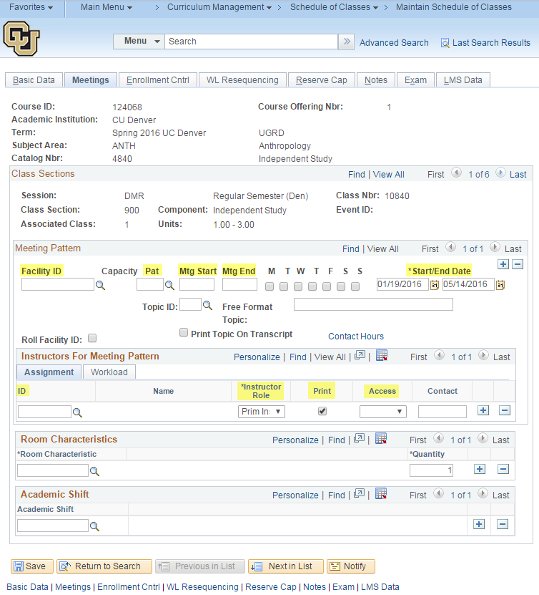
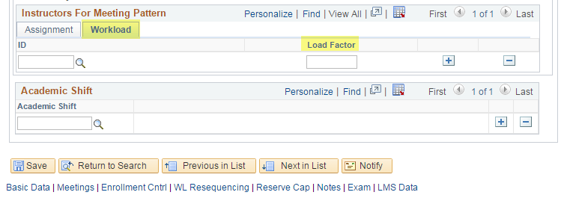

FIELD | How to complete this field
FACILITY ID | Enter proprietary rooming info here. Refer to the Rooming Schedule before adding anything here. Approximately a month prior to registration opening, all rooming must be requested through the Rooming Coordinator (including proprietary rooms).
MEETING PATTERN | BLANK unless meeting in person or hybrid.  What day(s) does the class meet?  Ex. MWF  Use pre-set pattern from magnifying glass whenever possible, otherwise manually select the days by checking the boxes.
START/END DATE | What time of day does class start/end? For classes that do not have the same meeting pattern each week, you will need to add a row by clicking the plus (+) sign and create each pattern as separate rows  *DMV/DCV session- Dates need to match/fall within the date range on the Basic Data tab.
INSTRUCTOR/TA | Enter instructor/TA's 9-digit ID or find them by name by clicking the magnifying glass
INSTRUCTOR/TA ROLE | Select the appropriate role.  Primary Instructor – Only 1 primary is allowed per section.  Secondary Instructor  TA
PRINT INSTRUCTOR IN CLASS SCHEDULE | Select the appropriate choice to show or hide the instructor/TA when students search for this class/enroll
GRADE ACCESS | Select the appropriate grade access  Primary Instructor – Post  Secondary Instructor – Grade  TA – Grade or blank
INSTRUCTOR WORKLOAD % | One instructor= 100%  Two or more instructors= appropriate percentage for each equaling 100% total  TA's= 0%

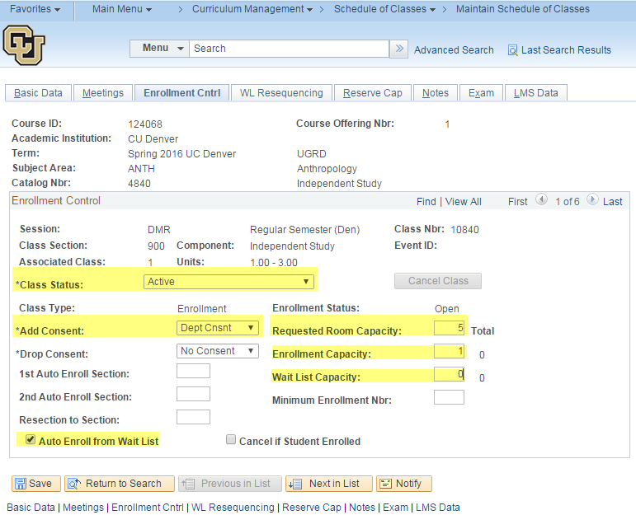

FIELD | How to complete this field
CLASS STATUS | Active
ADD CONSENT | Advertised Section: Department Consent (prevents students from registering without permission)  Enrollment Section: Department Consent (prevents students from registering without permission)
ROOM CAPACITY | Enter appropriate room capacity based upon projected enrollment capacity
ENROLLMENT CAPACITY | Advertised Section: 1 (best practice)  Enrollment Section: Should always match the room capacity
WAITLIST CAPACITY | Enter a number if you would like a waitlist
AUTO ENROLL FROM WAIT LIST | Defaults to checked. If this box in blank, students will not roll in from the wait list

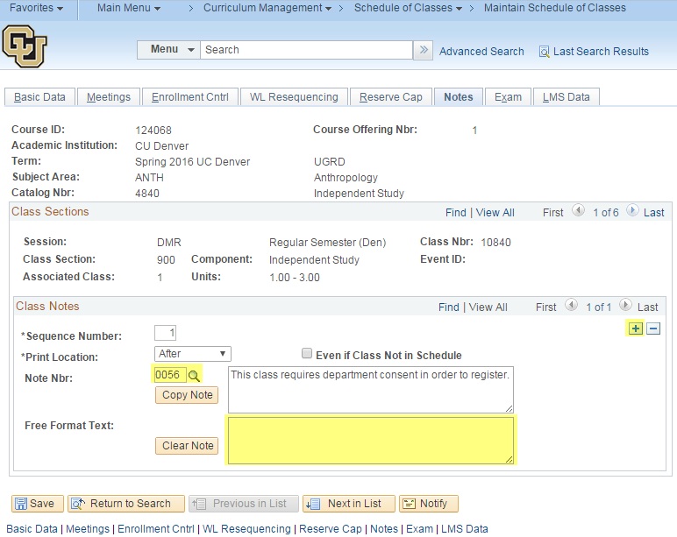

FIELD | How to complete this field
NOTE NBR | Select/enter a pre-built note number
FREE FORMAT TEXT | Enter additional information about this section
Add a row if more than one note is needed. Cannot have both a Note Nbr and a Free Format Text on the same row.

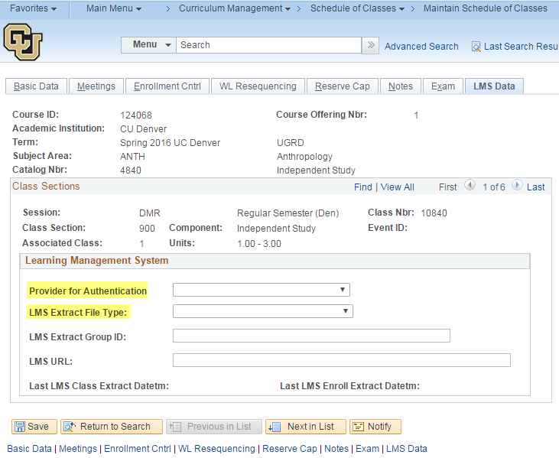
FIELD | How to complete this field
PROVIDER FOR AUTHENTICATION | Advertised Section: BLANK  Enrollment Section: To turn Canvas access on, choose CANVAS
LMS EXTRACT FILE TYPE | Advertised Section: BLANK  Enrollment Section: To turn Canvas access on, choose XML V1.1 (Canvas)

FYI's:
- Variable credit classes: If you have a variable credit class that you need to set at a fixed amount of units, please submit a Class Section Form immediately before students enroll. If students enroll before the credits are fixed, the section has to be cancelled and the students have to re-enroll. Examples of variable credit classes: Special Topics, Master's Thesis/Reports, Independent Study, etc.

- Combined Sections: If you need to make any meeting pattern or instructor changes to combined sections, you must use "Schedule Class Meetings" (Main Menu > Curriculum Management > Schedule of Classes > Schedule Class Meetings).

- Never reactivate a cancelled class. Instead, leave it cancelled and if necessary create a new, unique section in addition to the cancelled class.

- Never delete classes (never use the minus sign in "Class Sections" on the Basic Data tab).

- Enrollment capacity cannot exceed the capacity of the room.

