AGENDA
- Welcome & Introductions
- Advancement 101
- Building Donor Relationships
- Telling Your Story
- Our Campaign: Where We Are + Your Role
- Resources & Next Steps

ACTIVITY #1: TWO TRUTHS & A LIE – AN INTERACTIVE POLL
Scan the QR Code on the screen to join the poll group.
Note: You will be taken to a sign in page. Choose the SKIP button to join. Answers will be anonymous.
ACTIVITY #2: CASE & DISCUSSION WORK
Step 1 — Individual think I 60 seconds

SCENARIO: An alum has stayed connected to a faculty member for several years, attends occasional campus events, and recently expressed interest in the faculty member's work.
Then:

Step 2 — Breakout discussion (at your table/ virtual breakouts): 7–8 minutes
Each person answers:
- Where might this person be on the continuum?
- What would you want to learn?
- What could meaningful engagement look like?
- Where could Advancement help?

For repeat participants:
LEVEL UP: Where have you seen a similar opportunity in your own work?

Use a round-robin: Let's hear from each person for about a minute!

ACTIVITY #3: TELL YOUR STORY
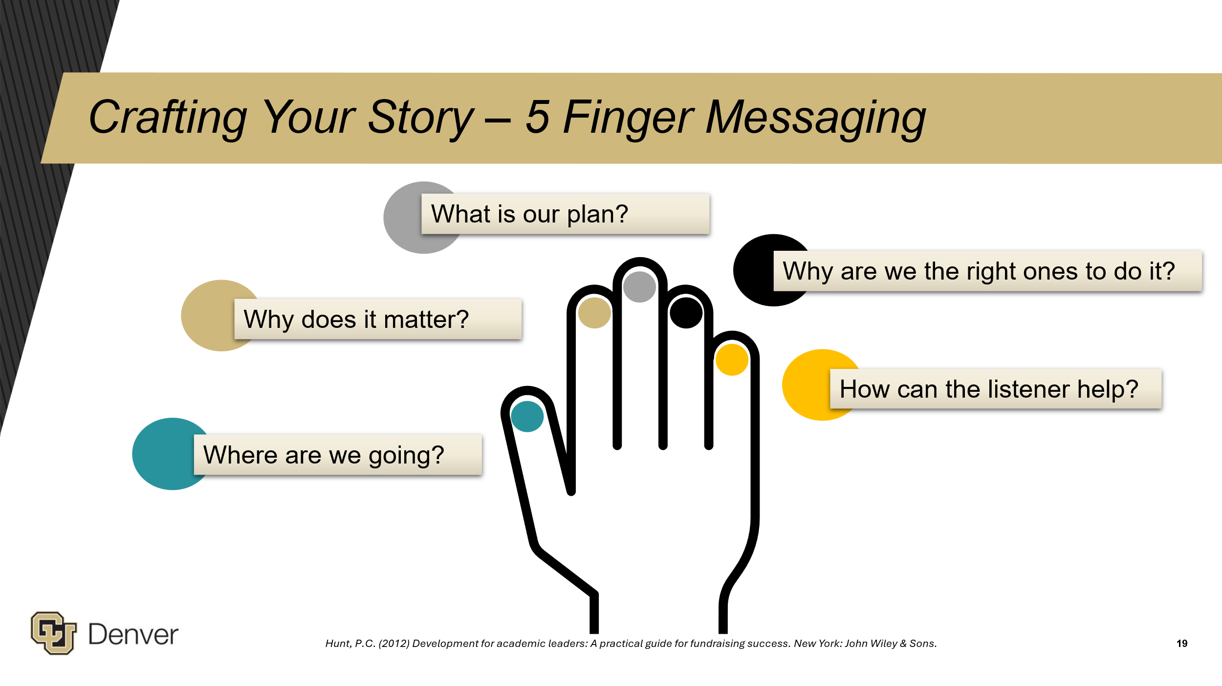
Hunt (2012)
Hunt, P.C. (2012) Development for academic leaders: A practical guide for fundraising success. New York: John Wiley & Sons.
Step 1 | 2 minute
Individually choose a program, initiative, research project, student experience, or opportunity you wish more people knew about.

Step 2 | 4 minutes
Jot down a few words using the Five Finger framework:
Why does it matter?
Where are we going?
What’s our plan?
Why are we the right ones?
How can someone help?

For repeat participants:
LEVEL UP: No jargon, acronyms, or program names.

Step 3 | 10 minutes
Discuss at your tables / virtual breakout rooms
Each person gets 60 seconds to tell their story.

Everyone else listens for:
What made you lean in?
After each story, give one quick piece of positive feedback: “What made me lean in was…”

Step 4 | 2 minutes
As a group, briefly consider:
Where might these stories connect to our larger campaign?

KEY TAKEAWAYS

Advancement
Advancement builds relationships and connects people with opportunities to make an impact at CU Denver.
- Prospect Research: Identifies and evaluates potential donors and opportunities.
- Alumni Relations: Builds and strengthens alumni connections.
- Fundraising/Major Gifts: Develops relationships that lead to philanthropic support.
- Planned Giving: Helps donors make future or legacy gifts.
- Annual Giving/Crowdfunding: Engages broad audiences in supporting CU Denver.
- Industry & Foundation Relations: Builds partnerships with corporations and foundations.
- Donor Stewardship: Thanks, engages, and demonstrates impact to donors.
- Strategic Communications: Shares CU Denver's stories, priorities, and impact.
- Events: Creates meaningful engagement experiences.
Remember: Advancement is an ecosystem—and campus is part of that ecosystem.

Relationship Development
Identification → Qualification → Cultivation → Solicitation → Stewardship
Fundraising is about relationships, not transactions. We follow the donor, listen for what matters to them, and look for authentic connections to CU Denver's work. Campus partners can contribute throughout the process—you are generally not expected to make the ask.

Telling Your Story
Move from “What do we do?” to “Why should someone care?”
Use Five Finger Messaging:
Why does it matter? • Where are we going? • What is our plan? • Why are we the right ones? • How can the listener help?

Our Comprehensive Campaign
CU Denver entered the public phase in February 2026. The public phase expands the circle: we deepen relationships, tell our story more broadly, invite greater participation, mobilize our community, and show momentum.
Our Focus Areas:
Expanding Access • Enhancing Student Success • Cultivating Human Talent

Your Role
SHARE what's happening. • CONNECT us to relationships and opportunities. • ENGAGE in experiences and conversations. • TELL THE STORY of why the work matters. • STEWARD by helping demonstrate impact.

You don't have to become a solicitor to be part of the campaign. Be a great partner in philanthropy.
Advancement Contact information:

- General information: ucdenver.edu/partneringwithadvancement
- Campaign information: ucdenver.edu/campaigninfo
- General support / inquiries: DASupport@UCDenver.edu

Upcoming Steps:
- Workshop Surveys
- Ongoing Advancement communications
- Spring Workshops

