University of Colorado Denver|Anschutz Medical Campus

Postdoctoral Office

GUIDEBOOK FOR POSTDOCTORAL FELLOWS

University of Colorado Denver|Anschutz Medical School
Guidebook for Postdoctoral Fellows
Table of Contents
- Welcome Message . . . . . . . . . . . . . . . . . . . . . . . . . . . . . . . . . . . . . . . . | Pg. 3
- Contacts . . . . . . . . . . . . . . . . . . . . . . . . . . . . . . . . . . . . . . . . . . . . . . . . | Pg. 4
- Postdoctoral Association . . . . . . . . . . . . . . . . . . . . . . . . . . . . . . . . . . . | Pg. 5
- Core Competencies . . . . . . . . . . . . . . . . . . . . . . . . . . . . . . . . . . . . . . . | Pg. 12
- Career Development . . . . . . . . . . . . . . . . . . . . . . . . . . . . . . . . . . . . . . . | Pg. 13
- Individual Career Plan . . . . . . . . . . . . . . . . . . . . . . . . . . . . . . . . . . . . . . | Pg. 14
- Annual Evaluation . . . . . . . . . . . . . . . . . . . . . . . . . . . . . . . . . . . . . . . . . | Pg. 20
- Salary and Benefits . . . . . . . . . . . . . . . . . . . . . . . . . . . . . . . . . . . . . . . . | Pg. 21
- Academic Year Calendar . . . . . . . . . . . . . . . . . . . . . . . . . . . . . . . . . . . | Pg. 22
- University Resources . . . . . . . . . . . . . . . . . . . . . . . . . . . . . . . . . . . . . . | Pg. 23
- Living in Metro Denver . . . . . . . . . . . . . . . . . . . . . . . . . . . . . . . . . . . . . | Pg. 24
- Wellness . . . . . . . . . . . . . . . . . . . . . . . . . . . . . . . . . . . . . . . . . . . . . . . .  - Constituent Diversity Questionnaire . . . . . . . . . . . . . . . . . . . . . . . . . . . | Pg. 25  Pg. 26
- Postdoctoral Fellow Policy . . . . . . . . . . . . . . . . . . . . . . . . . . . . . . . . . . | Pg. 27

WELCOME TO THE UNIVERSITY!
The Graduate School at the University of Colorado Denver|Anschutz Medical Campus (CU Denver/Anschutz) aims to become an internationally recognized center for excellence in graduate education, postdoctoral training, innovation, and leadership. As such, the mission of the Graduate School is three-fold in support of the University, our students, the faculty, and our training programs:
- EDUCATION: to enhance and advance outstanding educational experiences for all members of the university and the adjacent community through excellence in graduate education;
- INNOVATION: to encourage and support excellence and innovation in research, creative and scholarly work;
- LEADERSHIP: to recruit and train the next generation of highly educated leaders from diverse backgrounds to serve and lead in our communities, nation and the world.

The Graduate School values the highest standards of learning, discovery, and creative work in an atmosphere of inclusion, collaboration, and community, being guided by the highest standards of ethical conduct.

There are approximately 300 postdoctoral fellows every year at CU Denver/Anschutz, and as one of them, you are now a part of our mission – your success will help us achieve our goals. Thus, we are here to support you, and we encourage you to take advantage of all the professional and career development opportunities that we provide. This guidebook will serve as a comprehensive resource for you as you begin your time here, and can be used as a reference for any issues that you may encounter. So, welcome to the next phase of you career – I look forward to working with you!

Sincerely,

Bruce H. Mandt, Ph.D.
Director, Postdoctoral Office; Career Development Office
Graduate School
University of Colorado Denver|Anschutz Medical Campus

POSTDOCTORAL OFFICE AND CAREER DEVELOPMENT OFFICE
The mission of the Postdoctoral and Career Development Offices at CU Denver/Anschutz is to help postdoctoral fellows acquire the non-science skills and experiences they need to successfully transition in their careers, both inside and outside of academia. We strive to supplement the world-class research training at CU Denver/Anschutz with world-class "non-bench" training, in turn making CU Denver alumni highly sought-after employees in a myriad of professions.

The Postdoctoral and Career Development Offices are located within the Graduate School office on the 5th Floor of the West Wing of Building 500 (W5112) on the Anschutz Medical Campus. The office is typically staffed during normal business hours, and we hope you drop by as needed. However, you also should feel free to contact us via email or phone to set up an appointment that is more convenient for you.

Don’t be a stranger!

Bruce H. Mandt, Ph.D.
Director, Postdoctoral Office; Career Development Office

Email: bruce.mandt@ucdenver.edu

Phone: 303-724-2930
Office: Building 500, W5112
Websites: ucdenver.edu/postdoc; ucdenver.edu/career-development

Graduate School Main Office
Phone: 303-724-2911
Office: Building 500, W5108

Welcome!

We’re pleased to welcome you to the University of Colorado Denver | Anschutz Medical Campus Postdoctoral Association (PDA). As a Postdoctoral Fellow (postdoc), you are automatically a full member of the PDA and are encouraged to join us at any or all of our events.

The purpose of the PDA is to enhance the training experience for postdocs at CU Denver/Anschutz. This is done both by advocating for postdocs at the University level, as well as facilitating career development by providing opportunities to practice leadership, networking, and communication skills. The PDA works in collaboration with the Graduate School, working closely with Dean David Engelke, Associate Dean Inge Wefes, and Postdoctoral Office/Career Development Office Director Bruce Mandt. We also work alongside and support many career development groups on campus, including the BEST Program, Careers in Science Club (CIS), Academia Industry Alliance (AIA), Women in STEM, Junior Faculty meetup group, and others.

As the primary University-recognized group for postdocs, the PDA gives postdoctoral fellows a voice and the ability to change the University for the benefit of all. To date, the PDA has initiated and/or developed the following programs and benefits:
- Mandatory insurance benefits for postdocs working part time
- Eligibility for the CU Denver/Anschutz tuition waiver benefit
- Funding and setup of permanent lactation facilities in research buildings
- Reduced pricing for postdocs at the Anschutz Health and Wellness Center
- Access to University email for life
- Postdoc specific ID badges, increasing recognition of postdocs on campus
- Postdoctoral Research Day, which recognizes the contributions of postdocs to their fields, and Postdoctoral Appreciation Week, which recognizes the contributions of postdocs to the University community
- Project Bridge, a program that helps improve science communication skills of researchers and advocates for public science awareness
- Young Hands In Science, a community outreach program to teach STEM curricula in local elementary schools
- Support of industry- and government-based career development groups on campus

The PDA often has opportunities to put your career development skills into practice, and we hope you will join us at PDA events and meetings in the upcoming years. Every postdoc has ideas that will make the PDA and the University better, and we look forward to working together to make your postdoctoral experience at CU Denver/Anschutz Medical Campus the best it can be!

Best wishes for success in your new position,
CU Denver/Anschutz Postdoctoral Association

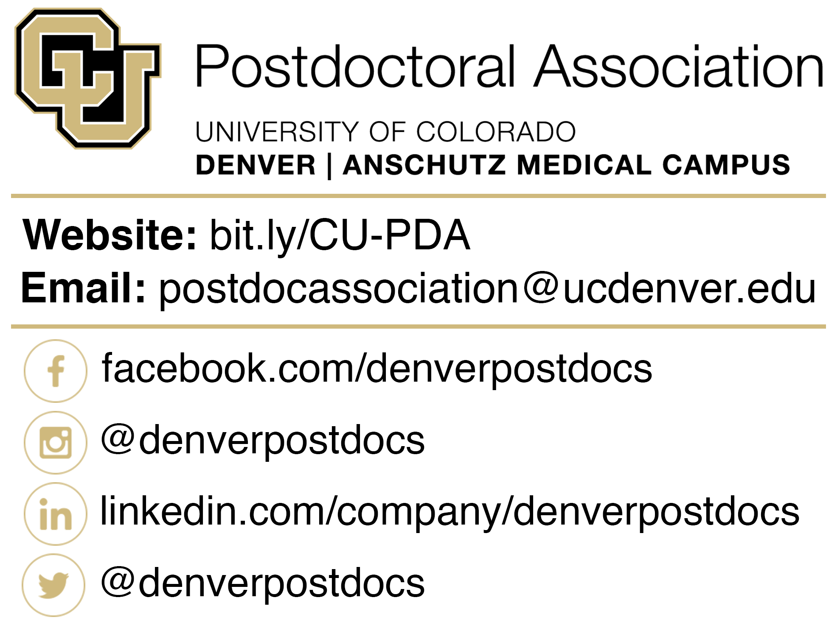

CU DENVER/ANSCHUTZ POSTDOCTORAL ASSOCIATION CHARTER
- Name and Purpose
  - The name of the organization is the University of Colorado Denver Postdoctoral Association (UCD-PDA).
  - The purpose of the UCD-PDA is to address the needs and concerns of postdoctoral fellows within the institution by promoting:
    - Advocacy
      - Provide representation to appropriate University committees and offices including:
        - UCD Graduate School Dean’s Postdoctoral Advisory Committee
        - Career Development Office (CDO)
        - And others as to further the postdoctoral association’s purpose
    - Career Development
      - Promote training environments which foster the career-related needs of the postdoctoral community
    - Community Development
      - Establish social and professional interaction within the UCD postdoctoral community and the surrounding community
- Membership
  - All postdoctoral fellows, defined as individuals carrying a doctoral degree and conducting research under a faculty member's supervision at the University of Colorado Denver, are automatically full members and shall constitute the full body of the UCD-PDA.
  - Only members can serve on the Executive Council.
  - Only members can serve as committee chairs.

- Executive Council
  - Duties of the Executive Council include (but are not limited to):
    - Representing the membership and their concerns
    - Conducting the business of the UCD-PDA
    - Attending and organizing regular Executive Council Meetings
  - Eligibility and Elections
    - Only members of the UCD-PDA are eligible for executive council.
    - Members should have been involved in events that promote postdocs or postdoc relevant causes prior to elections
    - Elections for Executive Council Officers shall occur in August of every year.
    - All UCD-PDA members present at the election meeting may vote
  - Officers
    - President
      - The president chairs the executive council, conducts all meetings, appoints and organizes committees with the advice and consent of the membership, and is the official representative of the UCD-PDA to the University.
    - Vice-president
      - The vice-president assists the president with UCD-PDA activities as needed, may serve as an alternate representative of the UCD-PDA to the University, coordinates voting for the UCD-PDA, and monitors eligibility of its members.
    - Secretary
      - The secretary will call UCD-PDA meetings, publicize them, and record minutes. Minutes will be distributed to UCD-PDA members within 7 days following the meetings.
      - The secretary is also primarily in charge of email communications.

    - Treasurer
      - The treasurer manages income and disbursement of all funds and properties at the disposal of the UCD-PDA. The treasurer is also responsible for submitting an annual budget to the Executive Council and Dean of the Graduate School.
    - Webmaster
      - The webmaster shall maintain the UCD-PDA website, including activities calendar. The webmaster shall also be tasked with creating and distributing surveys as needed.
    - Committee Chairs
      - Committee Chairs will also be members of the executive council. Specific duties for individual chairs are outlined in the “Committees” section.
- Committees
  - The UCD-PDA will have the following standing committees:
    - Postdoctoral Research Day Committee
      - Members of this committee are tasked with planning and organizing the annual postdoctoral research day.
      - Although not required, it is suggested that sub-committees include Fundraising, Publicity, and Secretary. Chairs of these sub-committees do not have to be members of the UCD-PDA.
    - International Committee
      - The international committee represents international postdocs and the related issues. They are responsible for providing programming relevant to international postdocs as well as bringing any issues to the attention of the membership.
    - Social Committee
      - As community development is 1 component of the UCD-PDA purpose, the social committee organizes events for postdocs to socialize with each other as well as with the rest of the UCD community.
    - Career Development Committee
      - Career Development is an essential component of the UCD-PDA purpose. This committee will organize workshops, speakers, and other events to further career development at UCD. It is essential that this committee work closely with the Career Development office and other entities that may be performing similar programming to ensure minimal overlap.
  - Ad hoc committees can be formed by the President with recommendation by the membership as needed and dissolved with the task is complete.
  - Chairs
    - Each committee will have at least 1 committee chair. Committees may have up to 3 co-chairs.
    - Chairs for the committee are elected in September along with Executive Council officers and serve as on the Executive Council.
    - Chairs must be members of the UCD-PDA.
    - Chairs are responsible for organizing the committee and reporting committee activities to the membership and executive council.
- Departmental Representatives
  - Departmental representatives must be members of the UCD-PDA.
  - Departmental representatives are expected to attend all UCD-PDA meetings.
  - Each department will determine their own method of electing or nominating representatives to the UCD-PDA.
  - Each department is allowed 1 representative for every 20 postdocs in that departments, with each department guaranteed a minimum of 1 representative.
  - Department representatives will be solicited from departmental chairs in June of each year, with terms beginning in September. The term for each representative is 1 year, with no limit on number of terms served.
  - Departmental representatives are tasked with disseminating information from the UCD-PDA to their departments (via email, flyer postings, word-of-mouth, etc.).
  - Appointments are for the duration of 1 year.
  - Representatives must attend at least half of all meetings to remain in good standing.
  - If a representative fails to attend 3 meetings in a row they will be notified by the PDA Secretary that they have been removed from their position.
  - Absences should be reported the Secretary at least 24 hours in advance of the scheduled meeting.
    - Representatives are encouraged to solicit an alternate from their department to attend the meeting.
- Meetings
  - Meetings for all members of the UCD-PDA will occur on the 2nd Monday of every month.
  - Meetings will be conducted using Robert’s Rules of Order.
  - Executive council officers, committee chairs, and department representatives are required to attend all meetings. Absences must be reported to the Secretary prior to the start of the meeting.
  - Meetings are open to all members of the UCD-PDA.
  - Non-members may be invited to attend meetings at the discretion of the executive council and invitation by the President.
- Voting
  - All members of the UCD-PDA present at the meeting will be eligible to vote.
  - Quorum will be had if 2/3 of the executive council is present.
  - Voting can only occur at scheduled meetings with at least 7 calendar days advance notice of a vote.
    - Exception to this only applies when the membership deems an issue of great importance to solicit votes from the entire membership and not only those in attendance of a meeting. These votes will be held electronically.
  - Motions will pass with a simple majority.
- Review
  - The PDA shall review the Charter at least annually to ensure that they remain current.
  - The president will announce the review period to EC members to allow input from all members.
  - Proposed changes to the Charter can be made at any time following discussion at a regularly scheduled committee meeting pending the vote of the PDA membership
  - Proposed changes should be submitted to the President and presented for discussion at the next scheduled PDA meeting
  - All proposed changes will be discussed and approved by a majority vote of the PDA members in attendance.

POSTDOCTORAL FELLOW CORE COMPETENCIES
The National Postdoctoral Association (NPA) has identified six core competencies that they believe postdoctoral fellows should acquire during the course of their training. Proficiency with these core competencies will help ensure that postdoctoral fellows develop the skills and abilities that will help them succeed both inside and outside of academia. The Postdoctoral and Career Development Office will assist with your professional development, but you should discuss these with your mentor, and if possible, incorporate them into your Individual Development Plan (see pg. 14).

You can find more information on the core competencies on the NPA’s website, but the list includes proficiency in the following areas:

- Discipline-specific conceptual knowledge
- Research skill development
- Communication skills
- Professionalism
- Leadership and management skills
- Responsible conduct of research

CAREER DEVELOPMENT OFFICE
One of the primary missions of the Career Development Office is to provide career and professional development opportunities for trainees. Consequently, we will offer various networking opportunities, workshops, and seminars throughout the year, which will focus on the key competency areas of communication, leadership and management, and professionalism. Although seminars and workshops are important for providing knowledge, applying this knowledge in real-world situations is essential to demonstrate your abilities. Take advantage of the opportunities provided by different campus groups to gather the career marketable experiences that will demonstrate your skills beyond the bench. Collectively, these opportunities will help you prepare for a myriad of professions, and we encourage you to take advantage of as many of these opportunities as possible – you never know what you might learn or whom you will meet!

You can check the current opportunities anytime on the Career Development Office website’s Events Calendar.

Additionally, you can get more information about acquiring “non-bench” skills and find a list of networking opportunities provided by different on-campus groups on the Career Development Office website (www.ucdenver.edu/career-development) on the “Getting Prepared” and “Getting Connected” pages, respectively.

The University of Colorado Denver|Anschutz Medical Campus also was awarded a National Institutes of Health Broadening Experiences in Scientific Training (BEST) grant in 2013, which is designed to augment the training environment for graduate students and postdoctoral fellows. The BEST program will offer additional career development opportunities throughout the year, and you can learn more at the BEST website.

Please contact Associate Dean Inge Wefes, Ph.D. (inge.wefes@ucdenver.edu; 303-724-7368) with questions about the BEST program.

INDIVIDUAL CAREER PLAN
Where do you want to go from here? This question is at the heart of the Individual Development Plan (IDP) or Individual Career Plan (ICP), and one of the best career decisions you can make right now is to begin thinking about what you ultimately want as your career. Although this may sound obvious, a detailed plan will help ensure that you are acquiring the skills and experiences necessary for a seamless career transition. Furthermore, an ICP will help you avoid the dreaded “now what?” moment that many postdocs experience near the end of their training.

One of the best ways to approach this process is to begin at the end (i.e., with your dream job!) and detail all the skills and experiences necessary for successfully obtaining that position. Revise your plan yearly with updates on progress and/or changes in your career pursuit, and you will ensure that you are on a path to success.

The American Association for the Advancement of Science (AAAS) has a developed a very useful IDP toolkit, called myIDP (http://myidp.sciencecareers.org), and there also are numerous other examples of IDPs online. You can begin the IDP process by reading this article about the IDP: http://www.sciencemag.org/careers/2012/09/you-need-game-plan. Once you are ready to start your ICP, though, feel free to use our user-friendly online ICP tool, which can be found at https://gs.ucdenver.edu/myicp/, or any of the IDP resources available online. An overview of this plan is included in the following section.

The ICP is YOUR career plan. Your mentor(s) should play an important role in helping you complete and refine your ICP, but you should invest some time reflecting on where you want to take your career and where you stand today BEFORE you meet with them. The general steps* in this process for you and your mentor(s) are outlined below.

Postdoctoral Fellow’s Steps:
Step 4: Complete your ICP draft and discuss it with your mentor(s). Your mentor(s) can help you complete and finalize your ICP. Then, discuss your ICP annually with your mentor(s), and update and revise as necessary.

Step 3: Reflect on, and assess, your current skillset and experiences.
Step 2: Identify what skills and experiences you need to achieve those goals.
Step 1: Define your long-term (i.e., your career), intermediate-term (e.g., end of your postdoc), and short-term (e.g., end of this year) goals.

Mentor’s Steps:
Step 1: Familiarize yourself with current career opportunities available to PhD scientists both inside and outside of academia.

Step 3: Establish regular (e.g., at least annual) reviews of the ICP, and help revise as necessary.
Step 2: Help your postdoctoral fellow complete and finalize their ICP. What are they missing that would be helpful for achieving their career objective?
*These steps are modifications of an IDP developed by the Federation of American Societies for Experimental Biology (FASEB), and the original FASEB IDP can be found here: http://www.faseb.org/portals/2/pdfs/opa/idp.pdf

INDIVIDUAL CAREER PLAN (ICP)

Postdoctoral Fellow’s Name:
Mentor’s Name:
Start date of this position: Current date:

Overview: The ICP can be your roadmap to success – so, take the time now to decide where you want to go! Your mentor(s) should be an integral part of your career development and you should discuss your ICP with them; however, BEFORE you meet with your mentor(s), you should spend some real time reflecting on where you want to take your career and where you stand today. Your mentor(s) can help you fill in the gaps, but this is YOUR plan – so get in the driver’s seat! In the future, the ICP can be used as an annual tool to track progress towards reaching your career goals, and you should revisit it often.

GOAL ASSESSMENT: The first step in defining your career goals is to identify the career you want to have. Once you have decided on your long-term career goal, you then can work backwards to identify the intermediate- and short-term milestones required to get there. Once you have defined your goal career and your plan for how to get there, you should discuss your plan with your mentor(s) and take advantage of their perspective and experience.

If you are unsure where you might go with your career, you can begin by taking the career interest assessment tools offered at myIDP (http://myidp.sciencecareers.org), or by exploring the following resources:
https://npamembers.site-ym.com/default.asp?page=CareerOptions
http://www.sciencemag.org/sites/default/files/documents/away_from_the_bench_1.pdf

Once you have identified your desired career, find a job posting for that position and use it to define the long-, intermediate- and short-term goals that will help prepare you to be a well-qualified applicant for that position.

Long-term Goal:
Prospective Date:

General qualifications and personal/professional skills needed to reach this goal (e.g., additional research methods, networking, interviewing, communicating, etc.):

Strategies for obtaining these qualifications and skills (e.g., specific career development workshops, conference attendance, campus organizations, etc.):

Intermediate-term (e.g., 3-5 years) goals:
Timeline:

General qualifications and personal/professional skills needed to reach this goal (e.g., additional research methods, networking, interviewing, communicating, etc.):

Strategies for obtaining these qualifications and skills (e.g., specific career development workshops, conference attendance, campus organizations, etc.):

Short-term (e.g., 1-2 years) goals:
Timeline:

General qualifications and personal/professional skills needed to reach this goal (e.g., additional research methods, networking, interviewing, communicating, etc.):

Strategies for obtaining these qualifications and skills (e.g., specific career development workshops, conference attendance, campus organizations, etc.):

SKILL ASSESSMENT: The next step in developing your ICP is to determine where you stand today. Identify the specific skills required to reach your long-, intermediate-, and short-term goals (e.g., an elevator pitch, grant writing, business management, professional networking, etc.), and then reflect on your current skillset.

Rank each skill on a scale from 1-5, where 1 = lowest level of proficiency and 5 = highest level of proficiency. The status of completion for each skill should be determined at your annual ICP review. Create as many skill profiles as necessary, and be as complete as possible for each specific skill.

Communication skills (e.g., elevator pitch, grant writing, etc.):

Current skill level:
Strategies needed to close the gap (e.g., workshops, courses, etc.):
Deadline:

Year:
Completion status:
Completed Progress No progress
Comments and/or evidence of progress:

Research/management skills (e.g., techniques, data analysis, etc.):

Current skill level:
Strategies needed to close the gap (e.g., workshops, courses, etc.):
Deadline:

Year:
Completion status:
Completed Progress No progress
Comments and/or evidence of progress:

Professional/Interpersonal skills (e.g., collaborating, networking, interviewing, etc.):

Current skill level:
Strategies needed to close the gap (e.g., workshops, courses, etc.):
Deadline:

Year:
Completion status:
Completed Progress No progress
Comments and/or evidence of progress:

ANNUAL EVALUATION
An annual performance review (APR) is an integral part of your career development. An APR allows you to learn what you did well over the past year, identify areas for advancement, and modify your activities accordingly. Each year, your research mentor will receive an automated email message instructing them to fill-out the online form. Once this is completed, you will receive an automated email message instructing you to review and acknowledge your APR. After you have reviewed your form, your departmental Director of Finance and Administration will receive notification, and they will submit final approval.

The University and funding agencies like the NIH and the NSF require an APR for postdoctoral fellows, and human Resources (HR) oversees the APR process for postdoctoral fellows, just as they do with annual reviews of regular employees. The Postdoctoral and Career Development Office is a resource for the HR professionals within individual Departments and Schools, and if there are questions, refer your departmental HR professional to the Postdoctoral and Career Development Office.

SALARY AND BENEFITS
Postdoctoral Fellows are hired directly by their faculty mentors and the Department and School in which they conduct their training. Guidelines for postdoctoral fellows’ salaries and benefits are described in the University of Colorado Denver|Anschutz Medical Campus “Policy for Research Postdoctoral Fellows-Trainees”, which can be found on the Postdoctoral Office website under the “For Administrators” page and at the end of this document.

All Postdoctoral Fellows employed 50% or more receive the same benefits, regardless of the source of their support. You can find your full benefits eligibility on the CU Employee Services website.

Briefly, benefits include the standard employee offerings and are subject to the same eligibility and usage requirements as other employment classifications and include the following items:

- Group medical and dental insurance
- Life and AD&D insurance
- Short and long-term disability
- Workers’ compensation
- Unemployment compensation
- Flexible Spending Accounts
- COBRA upon termination
- Tuition waiver benefit – *note that you must first register as a non-degree seeking student in the graduate school and registration deadlines apply.

Leave and Holidays: In addition to the holidays listed in the Academic Calendar (pg. 22), full-time postdoctoral fellows also receive 12 working days of vacation and 12 working days of sick leave per fiscal year (24 working days total, or 192 hours), and are eligible for Family Medical Leave similar to the standard criteria used for other campus employees.

ACADEMIC YEAR CALENDAR

You can find university holidays for your specific campus on the academic calendars on the registrar’s websites for the Denver Campus and the Anschutz Medical Campus.

In general, each campus observes the following holidays, but check with your specific department for verification.

Denver Campus Holidays:
- Memorial Day
- Independence Day
- Labor Day
- Thanksgiving Day
- Christmas Eve
- Christmas Day
- New Year’s Eve
- New Year’s Day

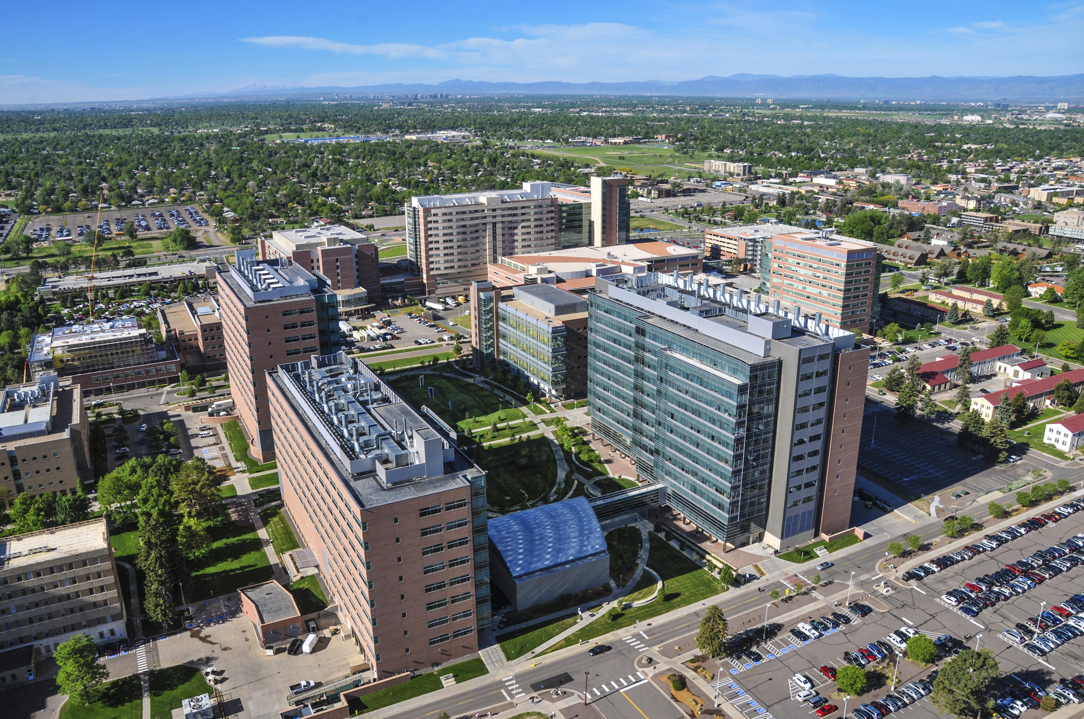
Anschutz Medical Campus Holidays:
- Martin Luther King, Jr. Day
- President’s Day
- Memorial Day
- Thanksgiving Day
- Thanksgiving Day after
- Christmas Eve
- Christmas Day
- New Year’s Day

UNIVERSITY RESOURCES
General University resources, policies, and procedures will be explained to you at your New Employee Orientation, and can be found in the New Employee Orientation packet. Instructions for New Employee Orientation registration can be found here. You also can find a list of University resources on the “Getting Started” page of the Postdoctoral and Career Development Office website.

Briefly, here are some of the resources that may be helpful for you as you begin your new position:
- Anschutz Medical Campus library: Health Sciences Library
- Denver Campus library: Auraria Library
- Faculty and Staff Threat Assessment and Response Team (FaST): The FaST team helps with issues of mental health crisis and can be reached by email or by phone at 303-315-0182.
- Office of Diversity and Inclusion
- Office of Research Development and Education (ORDE) - ORDE is one of the best places on campus to identify internal and external funding sources.
- The Ombuds Office and the CU Anschutz Office of Professionalism
  - The grievance policy can be found in the Policy for Postdoctoral Fellows on the Postdoctoral and Career Development Office website:
- The Writing Center at CU Anschutz
- The Writing Center at CU Denver
- University Research: This is the home for all research activities at CU Denver/Anschutz and provides a platform to navigate research infrastructure resources, expertise and best practices for researchers, study staff and administrators.

Resources for international postdoctoral fellows:
Your best resource for immigration and international-related questions is International Students and Scholars Services (ISSS) within the Office of International Affairs. Among other services, ISSS provides . . .
- Advice regarding status, employment, and travel
- One-on-one J-1 scholar orientations
- Cultural adjustment assistance for scholar and dependents
You can schedule an appointment with ISSS online or by calling 303-724-0795. They have office hours on both the Denver Campus and the Anschutz Medical Campus.

LIVING IN METRO DENVER
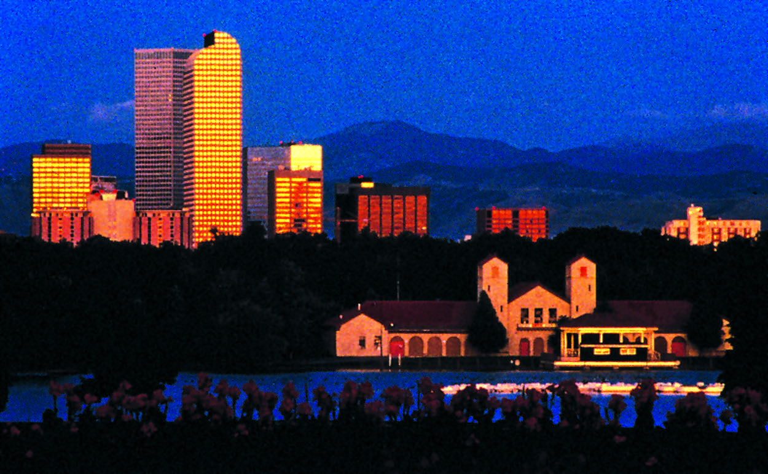
The Denver Metropolitan area continues to be one of the faster growing areas in the U.S. and boasts a robust economic forecast. With an average 300 days of sunshine a year and easy access to the beautiful Rocky Mountains, Denver’s appeal is not surprising. So now that you are part of the city, here are some resources that may be helpful as you navigate life in the Denver Metro area:

- Living in Denver
- Living in Aurora
- Housing: https://offcampushousing.ucdenver.edu/; Graduate School housing match service
- Childcare
- Commuting
- Parking on the Denver Campus
- Parking on the Anschutz Medical Campus: Parking on the Anschutz Medical Campus is free after hours (6pm to 6am) and on weekends. Just visit the parking office in Building 500 and to get evening and weekend parking access added to your badge (one time $10 activation fee applies).

One of the best ways to learn other helpful information about life in Denver is by talking to your fellow postdocs. You can find venues for networking and meeting other postdocs on the Career Development Office and Postdoctoral Association websites.

WELLNESS
During this extremely exciting, but stressful, time in your life, it’s important to remember to take care of yourself. Wellness encompasses many different aspects of your life (e.g., physical, mental, financial, spiritual, etc.), but the more you can incorporate wellness into your daily life, the happier and more productive you will be.

Here are some resources to help you maintain balance:

PHYSICAL WELLNESS: As the old adage goes, “a sound body equals a sound mind”. Whether it’s a weekend hike, an early morning spin class, incorporating walking meetings into your day, or simply standing up to stretch and move once an hour, physical activity is an essential part of wellness. Visit the Anschutz Health and Wellness Center for more details.

Campus Fitness Centers:
- Anschutz Medical Campus: Anschutz Health and Wellness Center – *the Postdoctoral Association has negotiated a discounted rate for postdocs, so make sure to ask for the postdoc rate ($35/month)
- Denver Campus: Campus Recreation at Auraria

MENTAL WELLNESS: Physical wellness is important for mental wellness, but the two are not synonymous. Mental wellness deserves explicit attention and should be part of your overall wellness plan. Whether it is formal counseling services, stress management, or just needing to talk with someone, everyone needs support from time-to-time. Make your mental wellness a priority and give it the attention it deserves.
- Anschutz Campus Health Center
- Denver Campus Counseling Center
- Ombuds Office
- In an emergency, call 911 or visit the Emergency Departments at the University of Colorado Hospital or Children’s Hospital Colorado

FINANCIAL WELLNESS: Although you do not receive a matched retirement contribution from the university, you can take advantage of their other retirement plans (e.g., 403(b), 401(k), 457) and services. Information on seminars, individual financial consulting, healthy financial habits, and more can be found on the Financial Wellness page of the Employee Services website.

CONSTITUENT DIVERSITY QUESTIONNAIRE

Goal
The University of Colorado Denver|Anschutz Medical Campus (CU Denver/Anschutz) works to diversify the biomedical science field by training exceptional scientists from all backgrounds. In conjunction with its overarching mission to promote broad diversity in its student population and its National Institutes of Health (NIH)-funded research endeavors, CU Denver/Anschutz seeks to recruit and retain individuals from underrepresented racial and ethnic groups, individuals with disabilities, and individuals from socially, culturally, economically, or educationally disadvantaged backgrounds.

In addition to helping the University fulfill its mission, belonging to one or more of these categories also may qualify you for certain funding opportunities or appropriate accommodations. For these reasons, we ask that you please complete an online survey indicating whether or not you self-identify with any of the groups listed above.

What is asked?
The very brief survey asks about race and ethnicity; disability; and social, cultural, or educational challenges.

How is it used?
When reported outside of the Graduate School, data collected here are always presented in a de-identified form, predominantly only in aggregate, and customarily only to organizations with a need-to-know status like the NIH or the National Science Foundation (typically in conjunction with applications for funding).

You can access the brief diversity questionnaire online at https://gaia.ucdenver.edu/diversity

Thank you for your assistance.

POLICY FOR POSTDOCTORAL FELLOWS
A. Introduction
Title: | Policy for Research Postdoctoral Fellows/Trainees
Prepared by: | Terry Potter,  Acting Dean of the Graduate School
Approved by: | Roderick Nairn  Provost and Vice Chancellor for Academic and Student Affairs  Kevin Jacobs  Assistant Vice Chancellor for Human Resources
Effective Date: | July 13, 2015
Replaces: | January 1, 2013
Applies: | Denver and Anschutz Medical Campuses

Research Postdoctoral Fellows/Trainees (also sometimes called postdocs, postdoctoral scholars, or “regular fellows,”) constitute one of the mainstays of the research enterprise at University of Colorado Denver I Anschutz Medical Campus. Because of their high level of education, Research Postdoctoral Fellows/Trainees (hereafter referred to as “Fellow[s] or postdoctoral fellows”) are able to work in a semi-independent manner on one or more research projects under the direction of the principal investigator with whom they are training.

B. Definition of a Research Postdoctoral Fellow/Trainee
This definition applies to all Fellows at the University regardless of their source of funding.
- The appointee holds a Ph.D. or equivalent doctorate (e.g., Sc.D., M.D., D.V.M.) in an appropriate field; and
- the appointee works under the supervision of a senior scholar; and
- the appointee has the freedom, and is expected, to publish the results of his or her research or scholarship; and
- the appointment is at will, transitional, and limited in time and scope; (See Section C below; and
- the appointment is usually made at a 1.0 FTE and postdoctoral fellows supported by a training grant must be appointed at a 1.0 FTE; and
- postdoctoral fellows who wish to be appointed at less than a 1.0 FTE, for example so that they may simultaneously explore other career opportunities, may submit a request explaining why they wish to be appointed at less than a 1.0 FTE. This request must include a description of the other source of employment in which they will be participating. Postdoctoral fellows who are approved for a less than a 1.0 FTE appointment are still required to sign and submit a conflict of interest form and are also bound by other policies of the university (such as the institutional intellectual property agreement); and
- the appointment is viewed as preparatory to a full-time academic and/or research career, including careers outside of the laboratory; and
- the appointment is not part of a clinical training program within a Graduate Medical Education program at the University of Colorado Anschutz Medical Campus; and
- given that the university considers these positions to be traineeships in highly specialized areas of study, and that these traineeships are required in order to realize full employment in the field, these positions will be defined as internships equivalent to the GME Residency program only for purposes of completing requests for student loan deferments.

C. Term Limits for Research Postdoctoral Fellow/Trainee Appointments
- A research postdoctoral fellow should have a maximum of six years of postdoctoral experience at the University. Time spent as a postdoctoral fellow at other institutions is not included in the six-year term limit.
- Individuals who are retained at the University beyond this six-year term limit should be placed into a regular job classification, such as Instructor, Research Associate, Senior Research Associate, or Assistant Professor.
- A research postdoctoral fellow and his/her faculty mentor may petition the Dean of the School in which the faculty member has their primary appointment for an extension to these terms.

D. Minimum Salary at Initial Appointment
- The suggested initial minimum stipend/salary for postdoctoral fellows is that defined in the current NIH training grant guidelines. http://grants.nih.gov/training/nrsa.htm All full-time postdoctoral fellows must receive a stipend either equal to, or above, the NIH guidelines for a postdoctoral fellow with no previous experience.
- Exceptions to this policy may be granted by the Dean of the School in which the faculty member has their primary appointment.
- This policy covers the salary requirements for all new hires as of July 2015. It is not the intent of the policy to enable decreases in the salary of individuals currently appointed as a postdoctoral fellow.
- In disciplines not funded by federal agencies, the Dean of the appropriate school or college will establish appropriate salary guidelines.

E. Grievance and Evaluation Processes
- Each School and College should establish their own procedures for handling grievances involving professionalism issues, salary, benefits and work conditions. Clear directions for how to appeal decisions will be developed by the School/College. The final decision rests with the Dean of the School/College in which the fellow is employed.
- Each postdoctoral fellow must receive an annual evaluation. This process can be completed according to the procedures adopted by the School/College into which the postdoctoral fellow is hired. In addition, for Schools and Colleges that would prefer that the Graduate School facilitate the evaluation of postdoctoral fellows, the Graduate School will provide an on-line application so that faculty can complete an annual evaluation of each of their postdoctoral fellows. The Graduate School will also provide the Department chairperson, or other direct supervisor of faculty who have postdoctoral fellows in their lab, an indication that this report was completed by the Faculty and seen by the fellow.

F. Uniform Benefits
- All research Postdoctoral Fellows/Trainees employed 50% or more receive the same benefits, regardless of the source of their support. See the Benefits Eligibility Matrix at the Employment Services website.
- Benefits include the standard employee offerings and are subject to the same eligibility and usage requirements as other employment classifications. This includes: group medical and dental insurance, life and AD&D insurance, short and long-term disability, workers’ compensation, unemployment compensation, Flexible Spending Accounts, and COBRA upon termination.
- Leave benefits for fellows/trainees employed 50% or more include:
o 12 working days of vacation and 12 working days of sick leave per fiscal year for a total of 24 working days (or 192 hours) for full-time positions per fiscal year.
o Accrued (unused) leave is carried forward year to year during the term of employment, but with no payout at termination.
o Maximum accrual is capped at 44 working days (or 352 hours) of combined sick and vacation leave.
o Accrual and usage follows the prevailing University practices used for other employee classifications. Hours shall be accrued each month at the rate of one day (or 8 hours) each for sick leave and vacation leave, and available for use at the beginning of the next month. Prorated leave shall be accrued for partial month hires and for appointment of at least 50 % but less than 100%.
o Postdoctoral Fellows are eligible for Family Medical Leave per the standard criteria used for other campus faculty positions.
o Postdoctoral Fellows are afforded leave in accord with University policy for all employees for holidays, military duty, bereavement, and jury duty.
o Should University, State, or federally-supported grant policies change, requiring equitable change in the number of leave days/hours afforded those in postdoctoral fellow positions, the changes will be adjusted accordingly and become effective without requiring formal amendment to this written policy.

G Periodic Review
- The Offices of the Provost and Human Resources will review this policy, and how it is being administered, on an ad hoc, as needed, basis, but no less frequently than every three years.

