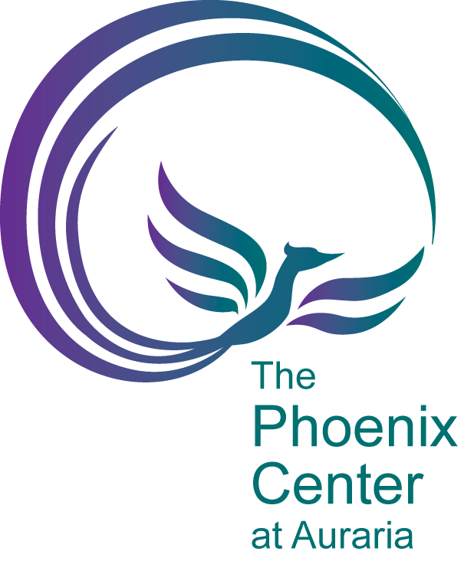

Annual Report 2015-2016

Table of Contents

Mission & Goals 3

Staff 5

Trainings, Outreach, and Education 6

Campus & Community Involvement 7

Utilization 8

Mission & Goals

Office Mission Statement

The Phoenix Center at Auraria's (PCA) mission is to implement campus response services, provide education, and facilitate dialogue related to interpersonal violence in the Auraria community. Through a dedication to the empowerment model of service and a seamless implementation of campus response services, we work to ensure that the students, faculty, and staff associated with Metro State University Denver, University of Colorado Denver, and Community College Denver (hereafter the tri-institutions) may continue pursuit of their educational, personal, and professional goals regardless of their experiences with interpersonal violence (IPV).

Office Goals
In June of 2015, the PCA outlined a number of goals for completion by the end of the 2015-2016 academic year. These goals are the following:
- Hire a new director
- Hire a new Violence Prevention graduate assistant
- Increase outreach to faculty and staff, resulting in a 25% increase in classroom presentation requests and faculty/staff trainings
- Launch new database to better track client data
- Pursue grant funding
- Launch Interpersonal Violence Online Training Module for CU Denver, CU Anschutz, and MSU Denver
- Secure funding for VPE Coordinator
Through pursuit of our goals and dedication to our mission as stated above we were able to accomplish all but two of our goals.

- We were able to hire two new graduate assistants to serve the PCA in a number of different capacities. Both are graduate students pursuing their Masters degrees in Social Work and were able to commit one year to serving the PCA as confidential advocates and peer educators.
- The PCA was able to moderately increase our outreach to faculty and staff which resulted in a 27% increase in classroom presentation requests. We look forward to continuing this trend and increasing it further in the year to come.
- We have begun utilizing the SalesForce database to better organize and compile client demographic data and have, thus, been able to remain in good standing with our grant funders.
- We were able to pursue grant funding through the Colorado Division of Criminal Justice and received both one time and recurring funds through the Victims of Crime Act in order to continue providing free and confidential services to the students, faculty, and staff associated with the tri-institutions.
- Our Interpersonal Violence 101 online training has been formally launched with CU Denver (“Not on my Campus”) and MSU Denver (“Roadrunners United”). We are continuing to pursue launch possibilities with CU Anschutz and CCD.
- We were not able to secure sustainable funding at this time for a Violence Prevention Education (VPE) Coordinator and the position has remained vacant since November of 2015.
- We were not able to hire a new director until October of 2016.

Longterm Goals

Also outlined in June of 2015 and amended on an ongoing basis is a list of longterm goals for the PCA:

2016

2017

2017

2018

2018

2019

Staff

Trainings, Outreach, and Education

The PCA is committed to preventing instances of relationship or intimate partner violence, sexual violence, and stalking through comprehensive education. The curricula offerings for the 2015-2016 academic year are as follows.
Interpersonal Violence 101
This session will provide a general overview of all aspects of interpersonal violence and will include interactive activities to help folks think about the dynamics of violence and issues such as consent, healthy relationships, and how to help a friend.
Healthy Relationships: What’s healthy? What’s hurting?
An interactive discussion in which Violence Prevention Educators and participants work to create a shared definition of healthy relationships (intimate or otherwise) by placing emphasis on the importance of our personal values, boundaries, and needs. The group will also explore healthy ways love is expressed, harbingers of relationships in trouble, and power and control dynamics. In this way the course works to empower participants with the knowledge and ability to differentiate among healthy, unhealthy, and abusive relationships.
Bystander Intervention
Have you ever wanted to step into a situation because you knew something was wrong, particularly if it is a friend you are worried about? This workshop discusses bystander intervention and works to develop strategies to intervene in difficult situations. The focus is on incidents of stalking, sexual assault and relationship violence, but principles can be applied to much more.
Media Literacy
This workshop provokes discussion about what interpersonal violence is and how media and pop culture messages contribute to the normalization of it in our culture. Through activities, images and video clips the concepts of sexual objectification and gender construction in the social media age will be illustrated. The discussion will also look at intersections of race, class, and power as they relate to interpersonal violence. This workshop is intended to help participants think critically about a media heavy society and how it can affect views on interpersonal violence and what individuals and groups can do to create social change.
Gender Construction
This workshop is designed to highlight how language and societally constructed gender roles can contribute to sexism and interpersonal violence. We will explore how and why a binary gender system contributes to interpersonal violence and how we can help disarm and shift harmful gender stereotypes. This workshop aims to deconstruct the social construction of gender and help attendees critically think about gender privilege, inequality, and interpersonal violence.

Community & Campus Involvement

Campus Committees

The Phoenix Center at Auraria is involved in a number of tri-institutional committees which are focused on providing students, faculty, and staff at each institution with an engaging and rewarding educational and professional environment. The PCA chairs the Outreach & Education committee which meets monthly to discuss PCA programming initiatives relevant to the campus community. The PCA also serves on the Sex Week Planning Committee, the MSU Denver Convening for Collaboration committee, the MSU Denver Sexual Assault Climate Survey Committee, and the Gender Equity committee.

Community Involvement

In addition to serving on various campus committees, the PCA also serves on the Sexual Assault Interagency Council, the Title IX Working Group, and the Campus Partners Group with various community stakeholders committed to keeping our metro area safe and engaging in trauma-informed practices.

2015-2016
Phoenix Center at Auraria
Utilization

Figure 2. Types of Service Provided. Figure 2 indicates the distribution of services provided to clients at their request during the 2015-2016 academic year. The balance of services provided to clients fall into our “advocacy appointment” category. Services provided during these appointments included but were not limited to included safety planning, housing assistance, navigating compensatory programs, crisis intervention, psychological first aid, and ongoing case management.
69%
5%
13%
13%
Figure 1. New, Unduplicated In-Office Clients. Figure 1 indicates the number of clients the PCA served according to institutional affiliation across three academic years. In 2015-2016, the PCA served 127 clients affected by interpersonal violence.

Figure 3. Violence Prevention Education Workshops. Figure 3 represents the number of workshops requested from and provided by the PCA according to academic institution across three academic years. In 2015-2016, we provided 92 education workshops compared to 71 the previous academic year.

Figure 4. Workshop Topics for 2015-2016 Academic Year. Figure 5 illustrates the topics that our Violence Prevention Education team provided during the 2015-2016 academic school year. IPV 101 and Bystander Intervention curriculums were the most popular by far, though the self-defense workshop received rave reviews by all participants.

