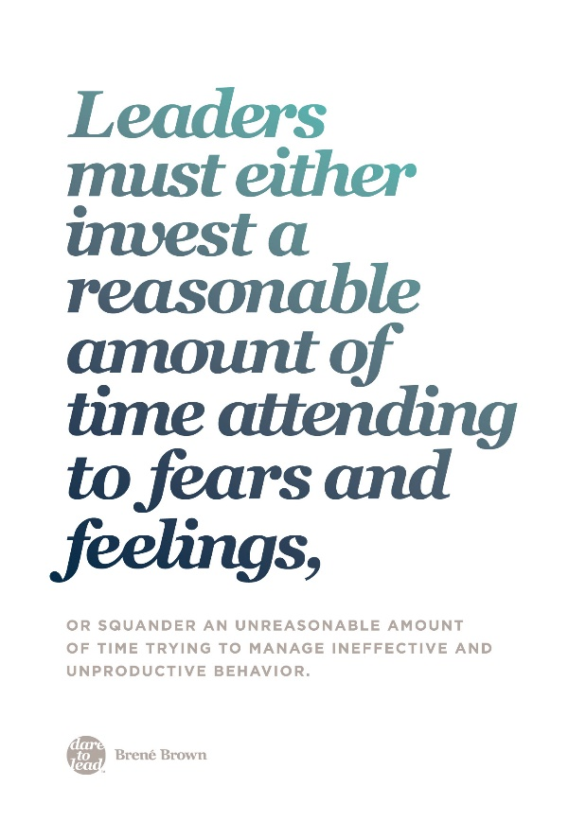
Crisis Management Best Practices and Considerations
Leadership skills to activate
Pause to engage your abilities to:
Anticipate – pause to predict and consider what lies ahead, respond not only to the immediate
Navigate – we’re in unprecedented times the path forward will change regularly, course correct in real time
Communicate – conscious and continuous communication. Apply TAUT and ask yourself is the message succinct and complete. Is content timely, accurate, useful and targeted to the audience?
Listen – to understand, listen to what’s being said and not said
Learn – lean on your past experience. Run the “unknown” of the current crisis against the “known” of previous ones, help yourself and others gain perspective, identify patterns, connect the dots, and determine appropriate and timely responses.
Lead – guide collective movement. Create directional vision and help others move together towards in the desired direction.
Crisis management in action
Start at the Bottom of Maslow’s Hierarchy
First, meet people where they are. Their most basic needs must be met and they need to feel safe. Once their essential needs are addressed, then the focus can shift to vision, alignment, common purpose, communal effort, and even opportunities for growth and learning.
Manage Expectations
When trouble strikes, people want it to be over right now — but seldom and not now - is quick resolution possible. Manage expectations for decision making, communications and information flow (timing – when, what and how often). And manage your own expectations.
Take a Moment to Figure Out What’s Going On
Listen, approach with curiosity – ask questions, assume positive intent
Anticipate
Pause and reflect What is the impact of the decision or action? What are the implications?
For example:
- If I respond to this one request can I anticipate there will be other similar requests? Will I be able to provide the same resource, response etc. to others? Are there fairness issues I should consider? Should I communicate to all?
- Do I have a mechanism in place for communications? Townhall? Daily summary? Weekly summary?
- Do I have all the information to decide? If not all, do I have enough? What or who might I need to consider? Do not be afraid to move forward without all the information. Course correct in real-time.
Urgent vs. Important
Act and decide promptly, not hurriedly. When a crisis hits everything blurs as events and their implications constantly change. What’s important often becomes urgent, and what’s urgent becomes critical. Pause to ask yourself and others: Is it urgent or important? Is it critical?
Build Connection
Crisis can create a sense of isolation. Actively strive to motivate, and inspire others, and show genuine compassion. Lead with humility and accountability, rather than hubris and bravado.
Empower Others
Enlist the knowledge, energy and resources of others – engages and motivates others, enables you to leverage yourself so that you accomplish far more than you individually can.
Know What to Do When You Don’t Know What to Do: The natural inclination in a crisis may be to go into command-and-control mode. Resist the natural inclination. There’s nothing like a crisis or a complex problem to accelerate learning. Remember it’s not all new.
Reflect on past experiences. What are your leadership strengths? What are the strengths of your team?
What remains the same? What skills, knowledge and experience can you leverage?
It is not about knowing what to do but about knowing what to do when you don’t know what to do. Remember, while it’s natural in uncertain times for people to turn to the leader for definitive answers, sometimes the authentic answer is “I don’t know right now” — quickly followed by, “And here’s what we are going to do.” In a crisis such as today, leaders need a Plan B — and a Plan C and perhaps Plan D.
Prioritize and Focus
Be more conscious about managing your time and priorities. Concentrate on only major issues for the immediate. Skip secondary tasks.
Maintain Perspective
During a crisis, leaders are often focused on the emotional turmoil of their direct reports and others in the organization, but it’s equally important for leaders to take care of themselves.
Whatever leadership role you play, you need to be aware of your own emotional turmoil, its effect on your behavior, and its influence on your leadership abilities. Take the crisis one day at a time, focus on the positive (avoid negative people, thoughts and negative talk), ground yourself in what’s important and how you want to show up for yourself and others, take a 5-minute private break (this is the most important time to “take 5” enable yourself to function at your highest cognitive and emotional capacity)
Sources:
Gemma D’Auria and Aaron De Smet, “Leadership in a crisis: Responding to the coronavirus outbreak and future challenges”, McKinsey and Co., March 2020
Klann, Gene, Crisis Leadership: Using Military Lessons, Organizational Experiences, and the Power of Influence to Lessen the Impact of Chaos on the People You Lead, Center for Creative Leadership, 2003
Brown, B. (2018). Dare to lead: Brave work.
Additional Recommended Resources
Harvard Business Review https://hbr.org/insight-center/coronavirus informative articles in many areas of crisis management and leadership / management. All applicable but not all specific to COVID-19 response (e.g.) Slow Down to Make Better Decisions, A Guide to Managing (Your) Newly Remote Workers, How Bad Times Bring Out the Best in People
George, B., VUCA 2.0: A Strategy for Steady Leadership in an Unsteady World, Forbes Magazine, 17 February 2017

